Smt.G.S.College,Vidyanagar,Jaggayyapet

Krishna Dist.,Andhra Pradesh

ANNUAL QUALITY ASSURANCE REPORT

**2013-14**

Track ID (of First Cycle): 07954

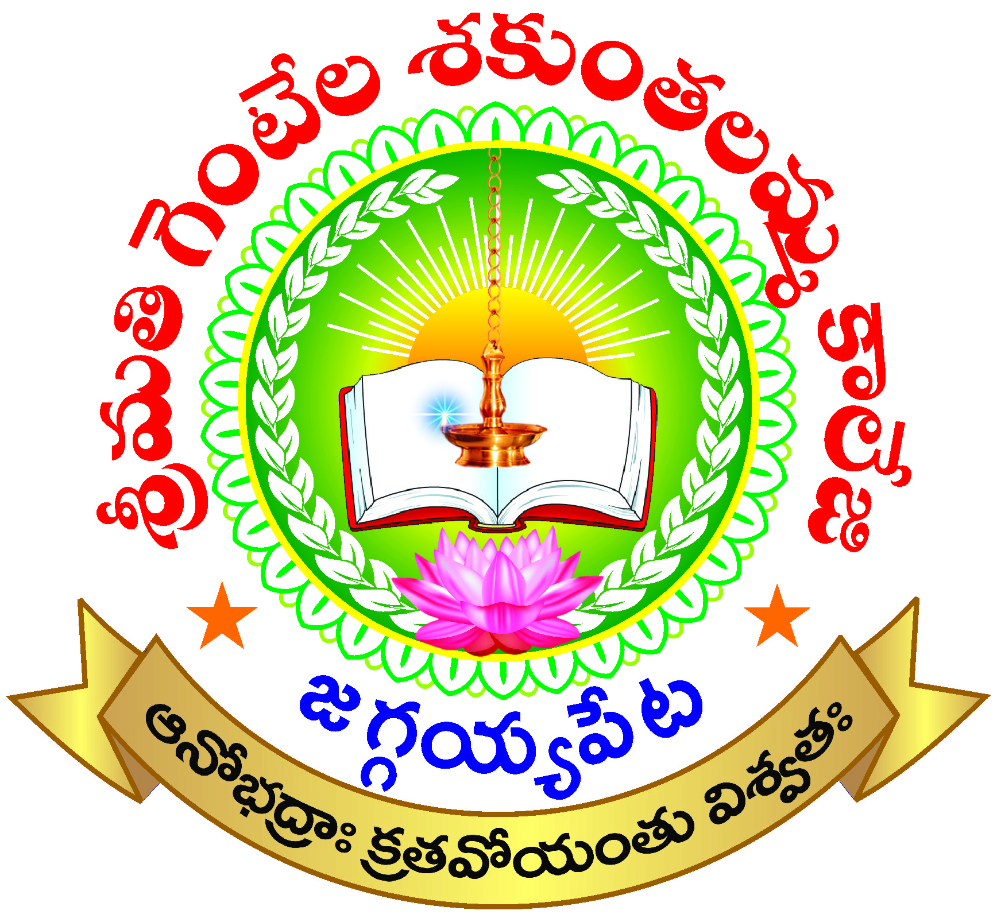

Submitted

To

**National Assessment and Accreditation Council**

**Bangalore**

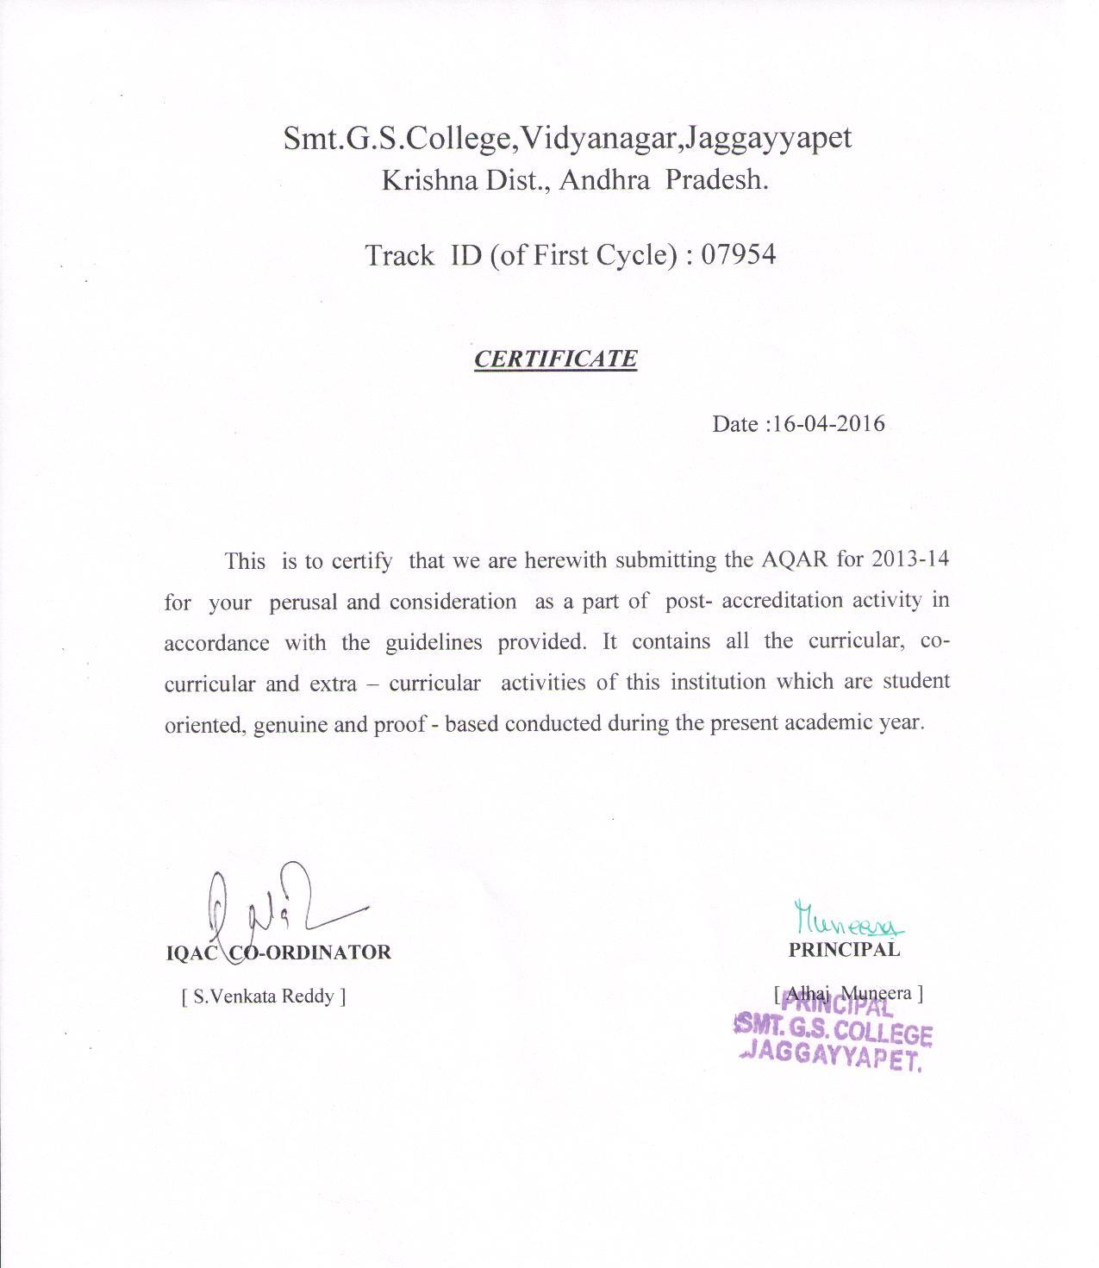

The Annual Quality Assurance Report (AQAR) of the IQAC

Part – A

**AQAR for the year**

**2013-14**

**1. Details of the Institution**

Smt.G.S. College

**1.1 Name of the Institution**

**1.2 Address Line 1**

Vidyanagar

Vijayawada Road

**Address Line 2**

Jaggayyapet

**City/Town**

Andhra Pradesh

**State**

521 175

**Pin Code**

sgs col.1968@yahoo.com

**Institution e-mail address**

08654 - 222090

**Contact Nos.**

Alhaj Muneera

**Name of the Head of the**

**Institution:**

08654 - 222090

**Tel. No. with STD Code:**

9490515038

**Mobile:**

**Name of the IQAC Co-ordinator:**

S.Venkata Reddy

9948192617

**Mobile:**

sgscol45iqac@gmail.com

**IQAC e-mail address:**

**(of the first cycle) 07954**

1.3 **NAAC Track ID** ***(For ex. MHCOGN 18879)***

EC/52/A&A/25 dated 28-3-2010

1.4 **NAAC Executive Committee No. & Date:**

***(For Example EC/32/A&A/143 dated 3-5-2004.***

***This EC no. is available in the right corner- bottom***

***of your institution’s Accreditation Certificate)***

www.sgscollege.info

**1.5 Website address:**

<http://sgscollege.info/AQAR>-2013-14.docx

**Web-link of the AQAR:**

**For ex. http://www.ladykeanecollege.edu.in/AQAR2012-13.doc**

**1.6 Accreditation Details**

|  |  |  |  |  |  |
| --- | --- | --- | --- | --- | --- |
| Sl. No. | Cycle | Grade | CGPA | Year of Accreditation | Validity Period |
| 1 | 1st Cycle | B | 2.70 | 2010 | 5 years |
| 2 | 2nd Cycle |  |  |  |  |
| 3 | 3rd Cycle |  |  |  |  |
| 4 | 4th Cycle |  |  |  |  |

09/07/2013

**1.7 Date of Establishment of IQAC : DD/MM/YYYY**

**1.8 Details of the previous year’s AQAR submitted to NAACafterthe latest Assessment and Accreditation by NAAC (*(for example AQAR 2010-11submitted to NAAC on 12-10-2011)***

1. AQAR_____2010-11_____________ ____________ (DD/MM/YYYY)
2. AQAR_____2011-12_____________ ____________ (DD/MM/YYYY)
3. AQAR_____2012-13 _____________ ____________ (DD/MM/YYYY)
4. AQAR 2013-14 submitted to NAAC (16/04/2016)
5. AQAR 2014-15 submitted to NAAC (16/04/2016)
6. AQAR 2015-16 submitted to NAAC (16/04/2016)

**1.9 Institutional Status**

√

**University** State Central Deemed Private

√

**Affiliated College** Yes No

**Constituent College** Yes No

√

√

**Autonomous college of UGC** Yes No

√

**Regulatory Agency approved Institution** Yes No

**(eg. AICTE, BCI, MCI, PCI, NCI)**

√

**Type of Institution** Co-education Men Women

√

Urban Rural Tribal

**Financial Status** Grant-in-aid UGC 2(f) UGC 12B

√

√

Grant-in-aid + Self Financing Totally-Self-Financing

√

**1.10 Type of Faculty/Programme**

√

√

Arts Science Commerce Law PEI (Phys Edu)

√

TEI (Edu) Engineering Health Science Management

    Career Oriented Programmes

Others (Specify)

Krishna University, Machilipatnam

NNal

**1.11 Name of the Affiliating University *(for the Colleges)***

***1.12* Special status conferred by Central/ State Government-- UGC/CSIR/DST/DBT/ICMR etc .**

**Autonomy by State/Central Govt. / University**

NA

Nil

Nil

**University with Potential for Excellence** UGC-CPE

Nil

Nil

**DST Star Scheme**  UGC-CE

Nil

Nil

**UGC-Special Assistance Programme** DST- FIST

NA

01

**UGC-Innovative PG programmes** Any Other (*Specify*)

02

**UGC-COP Programmes**

**2. IQAC Composition and Activities**

07

**2.1 No. of Teachers**

01

**2.2 No. of Administrative/Technical staff**

_

**2.3 No. of students**

**2.4 No. of Management representatives**

_

01

**2.5 No. of Alumni**

**2. 6 No. of any other stakeholder and**

01

**community representatives**

01

**2.7 No. of Employers/ Industrialists**

02

**2.8 No. of other External Experts**

**2.9 Total No. of members**

06

13

**2.10 No. of IQAC meetings held**

06

02

**2.11 No. of meetings with various stakeholders:** No. Faculty

01

02

01

Non-Teaching Staff Students Alumni Others

√

**2.12 Has IQAC received any funding from UGC during the year?** Yes No

Rs. 3,00,000/- -

**If yes, mention the amount**

**2.13 Seminars and Conferences (only quality related )**

(i**) No. of Seminars/Conferences/ Workshops/Symposia organized by the IQAC**

1

_

_

1

_

**Total Nos.** International National State Institution Level

The Role of IQAC in Quality Enhancement

**(ii) Themes**

**2.14 Significant Activities and contributions made by IQAC**

* Various academic and proficiency prizes were instituted and sponsored by the alumni , members of the Teaching and Non –teaching staff and members of the Management .They were given to the students who scored the highest marks and stood first in different subjects in the public exams.
* Faculty members are encouraged to help the poor and intelligent students to continue

and not to stop their studies because of financial problems .

* The members of IQAC made it a point to approach the old students, philanthropists , industrial people and lovers of education for developmental activities in the college.
* Compilation of research articles, abstracts and papers presented by the faculty in National and International Seminars and Workshops.
* In order to conduct **Internal Academic Audit**, a Core Committee, comprising the Principal, IQAC Coordinator, and senior faculty from Science, Commerce and Arts was constituted. The academic audit was held in the month of January 2014.
* **External Audit** was done by the ‘Academic Audit Team’ deputed by Commissioner of Collegiate Education, Andhra Pradesh on 25th March , 2014. The members of this Audit Team are : (1). G.Simhachalam, P.B.Siddhartha College ,Vijayawada , (2). Dr.Movva .Srinivasa Reddy , AndhraLoyola College,Vijayawada,
* To enhance the quality in education each department is provided with a pendrive and re –writable CDs to collect , store and use the data in their academic pursuit, research activities and in fostering innovative teaching – learning process.
* In order to conduct **Internal Academic Audit**, a Core Committee, comprising the Principal, IQAC Coordinator, and senior faculty from Science, Commerce and Arts was constituted. The academic audit was held on 27th January, 2015.

**External Audit** is done by the ‘Academic Audit Team’ deputed by Commissioner of Collegiate Education, Telangana on 28th January, 2015. The members of this Audit Team are **Mr. C. V. Ramana Reddy**, Asst. Professor, GDC Shadnagar, Mahaboobnagar dist., and **Mr. A.V. Ramesh**, Asst. Professor, GDC Sathupally, Khammam dist,.

* The IQAC coordinated with Department of **Chemistry** in organizing **National Seminar** on the theme – **“Recent Trends in Separation Process in Pollution Control”** on 12th and 13th of July, 2014. Keynote address in delivered by Dr. S. Sridhar, Principal Scientist – IICT, Hyderabad. Chief Guest for the Seminar Was Sri. Poola Ravinder, MLC. Guests of honor were Prof. P. Vinay Babu, JNTU and Sri. B. Kantha Rao, Secretary – Sri Sai Educational Insitutions, Kodad. This Seminar was a grand success with the active participation of nearly 200 Lecturers and Research Scholars.
* Department of **Telugu**, in collaboration with **Language and Cultural Department, Telangana government**, has organized one day **‘State Seminar’** on the topic **“Vattikota Alvaru Swamy - Life and Literature”** on 6th February, 2015. Keynote address is delivered by famous writer **Dr. Nandini Sidha Reddy**. Chief Guests for the occasion were **Sri. Desapathi Srinivas**, OSD Telangana government, and **Sri. Venu Sankoju,** renowned writer and poet.
* Neil Armstrong said “**Research is creating new knowledge**”. Our institution pioneered to inculcate scientific temper among the staff and students, and aim the arrows of their inquisitive insight to create new knowledge. The faculty are encouraged to pursue research by submitting their proposals to different funding agencies. **Mr. Ch. Rama Raju,** Asst. Professor in Botany, has registered for **Minor Research Project** (MRP) in **“Biological control of Fusarium wilt in Brinjal”.** **Mr. K. Nagi Reddy**, Asst. Professor in Chemistry, registered for **Minor Research Project (MRP)** on the topic – **“Reduction in COD level using activated carbon from natural resources: An economical viable solution for industrial, agricultural and domestic purposes”.**
* **“Ensuring quality higher education is one of the most important things we can do for future generation”** said Ron Lewis. To enhance the quality in education each department is provided with fully automated computers to enhance the quality in their academic pursuit, research activities and in fostering innovative teaching – learning process. This academic year printers and internet facility is also provided to all the departments.

|  |
| --- |
| * The IQAC works in collaboration as a team with the CDC and UGC units of the institution to identify the impediments in attaining quality in education and to explore the new schemes and grants for the improvement of quality in education and infrastructure as well.      * The faculty members are encouraged to pursue research in their respective fields of study.      * Faculty members are encouraged to sow the seeds of quest for research in the students by initiating **‘Student Study Projects’**. All the departments have been guiding the students on research methodology and encouraging them to prepare Study Projects. * IQAC maintains good relations with the **Alumni association** and involves the members in the development of the institution. * Faculty members of different subjects are encouraged to conduct **PG Entrance Coaching** for III year students aspiring to join Post Graduation in different Universities. * Remedial coaching was conducted for students with backlogs to enhance their learning capabilities and guidance was given to prepare them well in the exams. * Student feedback was collected very often and positive changes were made in teaching learning activity. |

**2.15 Plan of Action by IQAC/Outcome.**

The plan of action chalked out by the IQAC in the beginning of the year towards quality

enhancement and the outcome achieved by the end of the year *

|  |  |
| --- | --- |
| ***Plan of Action*** | ***Achievements*** |
| * To prepare Annual Academic Plan in the beginning of the academic year to streamline and coordinate all the stakeholders towards the common aim of attaining quality in education. * The IQAC deems it necessary to coordinate with CDC and UGC units of the institution to reach the goal of quality education. * To organize National Seminars ,Heads of Departments are enthused to take measures for applying and organizing National or State seminars * To provide rewards, recognition and incentives to encourage the students to be regular to the college and to put in more efforts in preparing for university exams. * To conduct Orientation to all the newly admitted students to the college. * To identify both slow learners and fast learners in each class and to adopt measures to alter the quality of input to be given to them as per their capability. * To encourage the faculty to use ICT and other innovative practices to enhance teaching-learning process. * To strengthen ‘Women Empowerment Cell’ and to organize more programmes on gender sensitisation. * Mentoring of students to be done by making each lecturer the Incharge of 25 students. * Faculty members are encouraged to show inclination towards research and to apply for MRP from UGC. * To coordinate with Heads of respective departments to organize Student seminars, Department seminars, Guest Lectures and Extension Lectures to augment all round development of the students. * Measures to be taken for the speedy construction of Girl’s hostel building. * To conduct remedial classes for the slow learners. * Faculty are asked to encourage students to take interest in research and prepare a ‘Student study project’(SSP) * The college  **magazine** has to be maintained giving a window to the staff and students to express their views and exhibit their talents. * To facilitate wide and practical exposure to the students, it is decided to organize Field trips, Study tours and Industry visit. * To organize ‘**Campus Recruitments**” by inviting reputed companies to facilitate the students of rural areas to be absorbed into corporate employment * The construction of Indoor Stadium * To encourage students to participate in sports & games actively to become physically & mentally fit.   . | * Annual Academic Plan is prepared by the IQAC committee in consultation with all the departments .This Academic Plan is circulated among the departments. Respective departments prepared their own Academic Plan on the basis of the Institutional Academic Plan. * From the beginning of the academic year the IQAC has conducted meetings with the CDC and UGC units of the institution as and when necessary to identify the impediments in attaining quality in education and to explore the new schemes and grants for the improvement of quality in education and infrastructure as well.   The IQAC always tries its best to motivate the faculty to apply to the UGC for Minor / Major Projects.   * It also guides and encourages the faculty to prepare and send proposals to the UGC for financial assistance to organise national seminars . * Various academic and proficiency prizes in the form of books , medals (Gold /Silver ), and cash were instituted by the alumni , members of Teaching and Non-teaching staff and members of Management and they are given to the students who fare well in various subjects and stand first every year. * All the faculty members conducted orientation to the newly joined students in the first week of July, 2013. * The faculty, after the I Unit Test have identified and listed out both slow and fast learners of their respective classes. This helped in giving more attention to the slow learners and to give additional inputs to the advanced learners. * This academic year each department is provided with a pen drive. This facilitated the faculty to collect , store and use the data regarding updating their knowledge and using it in a separate e-class room established to enable faculty to demonstrate using PPT. * **Women Empowerment Cell is** functioning effectively in the institution for the past few years. Smt.V.Latha Manga Tayaru is the convener of the WEC . She initiated a couple of programmes to educate the girl students on health, hygiene and legal protections. * “ Aha Emi Ruchi ”, a programme for the girls to show up their cooking skills was organized in January 2014. * WEC organised a sensitization programme on “ Anti – Ragging on Campus ” on 5th July 2013. * A Rangoli Competition was conducted on Aug 26th 2013 * In view of International Literacy Day a panel discussion organised on “ Women Literacy in India on Sept . 8th 2013. * In view of International Women’s Day WEC was organised election competition & quiz competitions on 8th March 2014.        * Faculty members are given the responsibility of 25 students each to counsel, motivate and inspire. A separate ‘Complaint Box’ is arranged near the principil’s room to enable the students to ventilate their grievances. * Not applied. * Respective departments have conducted Student Seminars. Some departments have organized Department Seminars. * Guest lectures and extension lectures on various topics have been conducted. * Department of PG **Commerce** organized an extension lecture on Career Path : Ushering Post Graduates into Lucrative Prospects by Dr.M.Babu Reddy , Krishna University, Machilipatnam. * The construction of **Girl’s Hostel Building** was completed with the untiring efforts of the institution. This Hostel was inaugurated on 31st July, 2013 . * The faculty were motivated and directed to conduct remedial classes for the slow learners as per their convenience and clarify their doubts . * The faculty members took sincere efforts to encourage students to take up research activities.All most all the departments of UG & PG Courses have involved their students in Study Projects . * It is being brought out every year. Students and staff are contributing their articles to the magazine. * Respective departments are organizing field trips , study tours and Industry visits * It was not successful but faculty were guiding the students for their absorption into employment in various fields off campus . * It has been in progress. In addition to UGC funds , donations have been also collected from the alumni, philanthropists etc. * The Department of Physical Education organizes various games and sports for the students * This year our college conducted Inter- Collegiate Kabaddi Tournament for men under the jurisdiction of Krishna University ,Machilipatnam on 23rd & 29th Oct.2013. * Mr. P.Sudhakar of II B.Com represented Krishna University Kabaddi Team at South Zone Inter –University Tournment at Alagappa University, Tamilnadu. * Mr. I. Gopala Rao of III B.Com represented Krishna University Tournment at Acharya Nagarjuna University , Guntur. |

√

**2.15 Whether the AQAR was placed in statutory body** Yes No

√

Management Syndicate Any other body

**Provide the details of the action taken**

The AQAR was placed before the CDC & Staff Council. It was approved by them. The CDC approved the Annual Action plan in the beginning of the year and permitted the IQAC to implement it.

Part – B

**Criterion – I**

**1. Curricular Aspects**

* 1. **Details about Academic Programmes**

|  |  |  |  |  |
| --- | --- | --- | --- | --- |
| **Level of the Programme** | **Number of existing Programmes** | **Number of programmes added during the year** | **Number of self-financing programmes** | **Number of value added / Career Oriented programmes** |
| PhD | - | - | - | - |
| PG | 03 | - | 03 | - |
| UG | 05 | - | - | 02 |
| PG Diploma | - | - | - | - |
| Advanced Diploma | - | - | - | - |
| Diploma | - | - | - | - |
| Certificate | - | - | - | - |
| Others | - | - | - | - |
| **Total** | 08 | - | 03 | 02 |

|  |  |  |  |  |
| --- | --- | --- | --- | --- |
| Interdisciplinary | - | - | - | - |
| Innovative | 01 |  | - | - |

**1.2 (i) Flexibility of the Curriculum: CBCS/Core/Elective option / Open options**

**(ii) Pattern of programmes:**

|  |  |
| --- | --- |
| **Pattern** | **Number of programmes** |
| Semester | 08 |  |  |  |
| Trimester | - |
| Annual | - |

√

√

1.3 Feedback from stakeholders* Alumni Parents Employers Students

√

***(On all aspects)***

√

Mode of feedback : Online Manual Co-operating schools (for PEI)

***\*Please provide an analysis of the feedback in the Annexure***

**1.4 Whether there is any revision/update of regulation or syllabi, if yes, mention their**

**salient aspects.**

Syllabi and curricula are followed as designed by the affiliating university, that is, Krishna University, Machilipatnam . This academic year also the affiliating university has not made any revision /changes in the syllabi..

1**.5 Any new Department/Centre introduced during the year. If yes, give details.**

No

**Criterion – II**

**2. Teaching, Learning and Evaluation**

|  |  |  |  |  |
| --- | --- | --- | --- | --- |
| **Total** | **Asst. Professors** | **Associate Professors** | **Professors** | **Others** |
| 16 | 03 | 13 | - | - |

**2.1 Total No. of permanent faculty**

03

**2.2 No. of permanent faculty with Ph.D.**

|  |  |  |  |  |  |  |  |  |  |
| --- | --- | --- | --- | --- | --- | --- | --- | --- | --- |
| **Asst. Professors** | | **Associate Professors** | | **Professors** | | **Others** | | **Total** | |
| R | V | R | V | R | V | R | V | R | V |
| - | 03 | - | - | - | - | - | - | - | - |

**2.3 No. of Faculty Positions**

**Recruited (R) and Vacant**

**(V) during the year**

**2.4 No. of Guest and Visiting faculty and Temporary faculty**

17

-

-

**2.5 Faculty participation in conferences and symposia:**

|  |  |  |  |
| --- | --- | --- | --- |
| **No. of Faculty** | **International level** | **National level** | **State level** |
| Attended Seminars/ Workshops | 01 | 11 | 07 |
| Presented papers | - | 03 | - |
| Resource Persons | - | - | 03 |

* 1. **Innovative processes adopted by the institution in Teaching and Learning:**

|  |
| --- |
| * The faculty encourages students to work hard and study well to bag academic and proficiency prizes ( Books, Gold /Silver medals , cash prizes etc.) * The papers and articles presented by the faculty in different State, National, and International Seminars are compiled. * To facilitate wide and practical exposure to the students, it is decided to organize Field trips, Study tours and Industry visits. Departments of Botany, Zoology,Physics, Chemistry , Commerce and History have organized field trips to Krishi Vignan Kendram – Garikapadu ,Rachem Industries, Mukthyala ,Ramco Cements Pvt. Ltd.,Jayanthipuram , Big Bazaar ,Vijayawada, Pulichinthala Project ,Dhanambodu , JPT and Kotilingala Mukthyala respectively. Department of Commerce organized a study tour to Best Price ( WalMart ) . * Career Guidance Cell of our institution takes keen interest in building the confidence among the students in practicing **Spoken English** and also equipped them with **Personality Development skills and Soft skills**. Every year the CGC takes initiative to organize ‘Of Campus Job Drive’ . * For PG students every Saturday of a week is a Special Day ,for the Director, PG Studies organizes a guest / extension lecture on subject – related or career options related or career guidance related or personality development related or communication and soft skills related topics or innate talents show- up related programmes. |

**2.7 Total No. of actual teaching days**

220

**during this academic year**

NA

2.8 **Examination/ Evaluation Reforms initiated by**

**the Institution (for example: Open Book Examination, Bar Coding,**

**Double Valuation, Photocopy, Online Multiple Choice Questions)**

-

-

-

2.**9 No. of faculty members involved in curriculum**

**restructuring/revision/syllabus development**

**as member of Board of Study/Faculty/Curriculum Development workshop**

75%

**2.10 Average percentage of attendance of students**

**2.11 Course/Programme wise distribution of pass percentage: (2013-14)**

|  |  |  |  |  |  |  |
| --- | --- | --- | --- | --- | --- | --- |
| ***Title of the Programme*** | ***Total no. of students appeared*** | ***Division*** | | | | |
| ***Distinction %*** | ***I %*** | ***II %*** | ***III %*** | ***Pass %*** |
| ***B.A III*** | 12 | - | 50 | 25 | - | 75 |
| ***B.Com III*** | 35 | - | 60 | - | - | 60 |
| ***B.Sc III*** | 16 | - | 50 | - | - | 50 |
| ***M.Sc (Physics)*** | 08 | - | 75 | - | - | 75 |
| ***M.Sc***  ***(Chemistry )*** | 10 | - | 50 | - | - | 50 |
| ***M.Com (Retail Marketing)*** | 19 | - | 100 | - | - | 100 |

**2.12. How does IQAC Contribute/Monitor/Evaluate the Teaching & Learning**

**processes:**

|  |
| --- |
| The IQAC prepares the **Annual Academic Plan** incorporating curricular, co-curricular and extra-curricular activities in the beginning of the academic year itself. The IQAC coordinates its activities with CDC and other units of the institution. It takes measures to identify both slow and fast learners in each class after the 1st Unit test. On the basis of this evaluation the faculty alters their teaching learning processes. The Heads of all the Departments submit their departmental reports to the IQAC, on the basis of which remedial measures are taken. Feedback from the students, parents and other stakeholders are obtained at regular intervals. |

**2.13 Initiatives undertaken towards faculty development**

|  |  |
| --- | --- |
| ***Faculty / Staff Development Programmes*** | ***Number of faculty benefitted*** |
| Refresher courses | - |
| UGC – Faculty Improvement Programme | - |
| HRD programmes | - |
| Orientation programmes | 02 |
| Faculty exchange programme | - |
| Staff training conducted by the university | - |
| Staff training conducted by other institutions | - |
| Summer / Winter schools, Workshops, etc. | - |
| Others | - |

**2.14. Details of Administrative and Technical staff**

|  |  |  |  |  |
| --- | --- | --- | --- | --- |
| **Category** | **Number of Permanent**  **Employees** | **Number of Vacant**  **Positions** | **Number of permanent positions filled during the Year** | **Number of positions filled temporarily** |
| Administrative Staff | 05 | 06 | - | 06 |
| Technical Staff | 02 | 02 | - | 02 |

**Criterion – III**

**3. Research, Consultancy and Extension**

**3.1 Initiatives of the IQAC in Sensitizing/Promoting Research Climate in the institution**

The IQAC has taken keen interest in promoting research aptitude among the teachers and the taught of the college. The faculty are encouraged to pursue research activities. For this purpose latest research equipment is provided in all science laboratories. The central library has the facility of INFLIBNET. Latest Reference Books and Journals are made available to all the faculty. The students are also encouraged to develop fascination towards research. They are motivated to prepare Student Study Projects. Field visits and educational tours are organized for the students. Visits to industries, research centres are arranged to ignite the spirit of enquiry among them. Science students are motivated to maintain the botanical garden by themselves to give them a practical exposure to different species of plants. Social sciences students are encouraged to take up social surveys to become aware of the methods of data collection.

The faculty are encouraged to pursue research by submitting their proposals to different funding agencies. Sri . Sd. Mir Hassim has registered himself for Ph.D. from Krishna University, Machilipatnam .

**3.2 Details regarding major projects**

|  |  |  |  |  |
| --- | --- | --- | --- | --- |
|  | **Completed** | **Ongoing** | **Sanctioned** | **Submitted** |
| Number | - | - | - | - |
| Outlay in Rs. Lakhs | - | - | - | - |

**3.3 Details regarding minor projects**

|  |  |  |  |  |
| --- | --- | --- | --- | --- |
|  | **Completed** | **Ongoing** | **Sanctioned** | **Submitted** |
| Number | - | - | - | - |
| Outlay in Rs. Lakhs | - | - | - | - |

**3.4 Details on research publications**

|  |  |  |  |
| --- | --- | --- | --- |
|  | **International** | **National** | **Others** |
| Peer Review Journals | - | _ | - |
| Non-Peer Review Journals | - | _ | - |
| e-Journals | - | _ | - |
| Conference proceedings | - | _ | - |

**3.5 Details on Impact factor of publications:**

-

-

-

-

Range Average h-index Nos. in SCOPUS

**3.6 Research funds sanctioned and received from various funding agencies, industry and**

**other organisations**

|  |  |  |  |  |
| --- | --- | --- | --- | --- |
| **Nature of the Project** | **Duration**  **Year** | **Name of the**  **funding Agency** | **Total grant**  **sanctioned** | **Received** |
| Major projects | - | - | - | - |
| Minor Projects | _ | _ | _ | _ |
| Interdisciplinary Projects | - | - | - | - |
| Industry sponsored | _ | - | - | - |
| Projects sponsored by the University/ College | _ | - | - | - |
| Students research projects  *(other than compulsory by the University)* | - | - | - | - |
| Any other(Specify) | - | - | - | - |
| Total | _ | _ | _ | _ |

_

**3.7 No. of books published** i) With ISBN No. Chapters in Edited Books

_

-

02

ii) Without ISBN No.

**3.8 No. of University Departments receiving funds from**

-

UGC-SAP CAS DST-FIST

-

-

DPE DBT Scheme/funds

-

-

**3.9 For colleges** Autonomy CPE DBT Star Scheme

-

-

-

INSPIRE CE Any Other (specify)

-

-

-

_

**3.10 Revenue generated through consultancy**

|  |  |  |  |  |  |
| --- | --- | --- | --- | --- | --- |
| Level | International | National | State | University | College |
| Number | - | - | - | - | 15 |
| Sponsoring agencies | - | - | - | - | Self-financed |

**3.11 No. of conferences**

**organized by the**

**Institution**

02

**3.12 No. of faculty served as experts, chairpersons or resource persons**

-

02

-

**3.13 No. of collaborations** International National Any other

12

**3.14 No. of linkages created during this year**

3**.15 Total budget for research for current year in lakhs :** Nil

-

From Funding agency From Management of University/College

-

Total

-

**3.16 No. of patents received this year**

|  |  |  |
| --- | --- | --- |
| **Type of Patent** |  | **Number** |
| National | Applied | - |
| Granted | - |
| International | Applied | - |
| Granted | - |
| Commercialised | Applied | - |
| Granted | - |

3.**17 No. of research awards/ recognitions received by faculty and research fellows**

**Of the institute in the year**

|  |  |  |  |  |  |  |
| --- | --- | --- | --- | --- | --- | --- |
| Total | International | National | State | University | Dist | College |
| - | - | - | - | - | - | - |

3.18 **No. of faculty from the Institution**

03

**who are Ph. D. Guides**

**and students registered under them**

03

NIL

**3.19 No. of Ph.D. awarded by faculty from the Institution**

**3.20 No. of Research scholars receiving the Fellowships (Newly enrolled + existing ones)**

-

-

JRF SRF Project Fellows Any other

-

-

**3.21 No. of students Participated in NSS events:**

-

100

University level State level

-

-

National level International level

**3.22 No. of students participated in NCC events:**

78

NA

University level State level

-

National level International level

12

**3.23 No. of Awards won in NSS:**

-

University level State level

-

National level International level

-

-

**3.24 No. of Awards won in NCC:** University level State level

-

NA

National level International level

-

-

**3.25 No. of Extension activities organized**

06

-

University forum College forum

NCC NSS Any other

02

-

04

**3.26 Major Activities during the year in the sphere of extension activities and Institutional**

**Social Responsibility**

|  |
| --- |
| * Our institution has a vast campus area of nearly 14.72 acres of land. Just like every year this year also the management of the college has permitted religious communities to organize their religious meets. * Our institution is proud to provide platform to the people of different walks of life and working in different sectors in and around Jaggayyapet to conduct various programmes , meetings , functions etc. It has taken keen interest in building the confidence among the students in practicing **Spoken English** and also equipped them with **Personality Development skills and Soft skills**. * Department of Political Science has organized an extension lecture on ***The Importance of Voters Enrolment***  on 25th January, 2015. * Besides education, the institution has made sincere efforts to provide Career Guidance not only to our students but even to other aspirants, enlightening them about the newly emerging employment opportunities. * The institution is privileged to have NSS & NCC units. NSS Special Camp was organized from 11th to 17th February,2015 at **Torragunta palem** village. Students are enlightened on the issues of social responsibility, environment protection, gender sensitivity etc. * Plantation was taken up by planting nearly 500 plants around the campus area. * Department of Zoology has organized ‘**Blood Grouping Camp’** for the students and the staff on 18th November, 2013. **Aids Rally** was taken up in the town. * NCC cadets extend their services round the year as and when necessary in the   matters of ***Town Traffic Control***  and ***Bandobusth*** at the places of worship on festival occasions. |

**Criterion – IV**

**4. Infrastructure and Learning Resources**

**4.1 Details of increase in infrastructure facilities:**

|  |  |  |  |  |
| --- | --- | --- | --- | --- |
| **Facilities** | **Existing** | **Newly created** | **Source of Fund** | **Total** |
| Campus area | 14.72 acres | - | Donation | 14.72 acres |
| Class rooms | 30 | - | - | 30 |
| Laboratories | 21 | 01 | UGC | 22 |
| Seminar Halls | 01 | - | - | 01 |
| No. of important equipments purchased (≥ 1-0 lakh) during the current year. | - | 149 | UGC | 149 |
| Value of the equipment purchased during the year (Rs. in Lakhs) | - | 450984 | UGC | 450984 |
| Others | _ | 132520 | UGC | 132520 |

**4.2 Computerization of administration and library**

Administration is fully computerised. There are 06 computers with internet facility. 75% of Library is also automated. Library is equipped with 02 computers with internet facility and INFLIB NET.

**4.3 Library services:**

|  |  |  |  |  |  |  |
| --- | --- | --- | --- | --- | --- | --- |
|  | **Existing** | | **Newly added** | | **Total** | |
| No. | Value | No. | Value | No. | Value |
| Text Books | 26799 | 858005 | 76 | 30996 | 26875 | 889001 |
| Reference Books | 2285 | 232168 | 54 | 7912 | 2339 | 240080 |
| e-Books | - | - | - | - | - | - |
| Journals | 1840 | 117000 | 35 | 23916 | 1875 | 140916 |
| e-Journals | - | - | - | - | - | - |
| Digital Database | INFLIB NET | 5000 | - | - | - | 5000 |
| CD & Video | 25 | 3500 | 10 | Supplied along with new books | 35 | 3500 |
| Others (specify) Vinar Racks | - | - | 01 | 11000 | - | - |

4.4 **Technology up gradation (overall)**

|  |  |  |  |  |  |  |  |  |
| --- | --- | --- | --- | --- | --- | --- | --- | --- |
|  | Total  Computers | Computer  Labs | Internet | Browsing Centres | Computer Centres | Office | Departments | Others |
| Existing | 62 | 02 | 05 | 01 | 01 | 01 | Library, M.Sc(Che)  M.Sc(Phy),  M.Com (R.M)  English | IQAC |
| **Added** | Nil | Nil | Nil | Nil | Nil | Nil | Nil | Nil |
| Total | 62 | 02 | 05 | 01 | 01 | 01 | 06 | 02 |

4.5 **Computer, Internet access, training to teachers and students and any other**

**programme for technology upgradation (Networking, e-Governance etc.)**

* Our institution provides computers with internet access to faculty and students. Library is fully automated with 02 computers with internet facility. INFLIBNET is also subscribed by the institution. Every year training in basic computer skills is imparted to faculty and also to non-teaching staff.

**4.6 Amount spent on maintenance in lakhs :**

54000

i) ICT

370000

ii) Campus Infrastructure and facilities

14467

iii) Equipments

-

iv) Others

438467

**Total :**

**Criterion – V**

**5. Student Support and Progression**

**5.1 Contribution of IQAC in enhancing awareness about Student Support Services**

* The IQAC helped the students to have easy access to all the relevant information regarding admission procedure, syllabus, examination pattern etc., by certain devices like –
  + Notice Board
  + College Brochure
  + Pamphlets
  + Press release.
  + Siti Cable
  + Mentoring System is adopted to give personal counselling to the students by Faculty to minimize dropout rate in the college.
* Student feedback is collected from the students once every academic year, and the opinion of the students is consolidated by the IQAC. Remedial measures are designed on the basis of the feedback given by students.
* The institution publishes its updated prospectus and handbooks annually. The information content is disseminated to students at the beginning of every academic year.
* Each department of the institution takes keen interest to conduct Elocution Competitions, Debates, Class room Seminars, Quizzes and Group Discussions to enhance the communicative and analytical Skills among the students.
* Special measures are taken to enhance Personality Development and Soft Skills among the students coming from rural background.

**5.2 Efforts made by the institution for tracking the progression**

* The institution is maintaining its contact with the previous students through college website and also its Social Networking site.
* Each department maintains an ‘Alumni Record’ consisting of the particulars of out going students.
* Alumni meetings are convened at least twice a year. A separate register is maintained to compile the particulars of the ex-students of the college.
* Some times accidental meetings of the faculty with the old students at functions, social gatherings , on certain important occasions etc give a scope for tracking the progression of the alumni. The Alumni association is motivated to contribute generously for the development of the institution.
* The Alumni association is motivated to contribute generously for the development of the institution.

**5.3 (a) Total Number of students**

|  |  |  |  |
| --- | --- | --- | --- |
| UG | PG | Ph. D. | Others |
| 278 | 118 | - | - |

**(b) No. of students outside the state**

Nil

Nil

**(c) No. of international students**

|  |  |
| --- | --- |
| No | % |
| 280 | 71% |

|  |  |
| --- | --- |
| No | % |
| 116 | 29% |

Men Women

|  |  |  |  |  |  |  |  |  |  |  |  |
| --- | --- | --- | --- | --- | --- | --- | --- | --- | --- | --- | --- |
| **Last Year** | | | | | | **This Year** | | | | | |
| General | SC | ST | OBC | Physically Challenged | Total | General | SC | ST | OBC | Physically Challenged | Total |
| 121 | 120 | 20 | 122 | 04 | 383 | 60 | 170 | 26 | 140 | 05 | 396 |

Demand ratio 1:1 Dropout : Nil

**5.4 Details of student support mechanism for coaching for competitive examinations (If any)**

* Besides regular instruction in curricular and co-curricular activities Career Guidance is offered to the students enlightening them about the newly emerging employment opportunities. Free coaching for Competitive exams like Group IV and Constables was conducted by the faculty for the college students and outsiders. Couple of departments have conducted PG Entrance Coaching.
* **Career Guidance Cell** of the institution always tries to be conversant about the syllabi and examination patterns for competitive exams. It gives proper guidance to the students regarding the newly emerging employment opportunities, patterns of entrance exam and the syllabi for such exams.

135

**No. of students beneficiaries**

**5.5 No. of students qualified in these examinations**

-

-

-

-

NET SET/SLET GATE CAT

IAS/IPS etc State PSC UPSC Others

-

-

-

-

**5.6 Details of student counselling and career guidance**

* Faculty members are given the responsibility of about 25 students each under the programme of **Ward Counselling**. **Career Guidance Cell** of our institution takes keen interest in building the confidence among the students in practicing **Spoken English** and also conducts classes on **Personality Development and Soft skills**.

120

**No. of students benefitted**

**5.7 Details of campus placement**

|  |  |  |  |
| --- | --- | --- | --- |
| ***On campus*** | | | ***Off Campus*** |
| Number of Organizations Visited | Number of Students Participated | Number of Students Placed | Number of Students Placed |
| _ | _ | _ | 200 |

**5.8 Details of gender sensitization programmes**

The institution has **Anti-ragging Committee** and **Women Empowerment Cell**. These two committees will take care of girl students of the institutions and their problems.

**5.9 Students Activities**

**5.9.1 No. of students participated in Sports, Games and other events**

02

Nil

63

State/ University level National level International level

No. of students participated in cultural events

Nil

Nil

Nil

State/ University level National level International level

**5.9.2 No. of medals /awards won by students in Sports, Games and other events**

Nil

Nil

02

**Sports** : State/ University level National level International level

Nil Nil

Nil

Nil

Nil

**Cultural**: State/ University level National level International level

**5.10 Scholarships and Financial Support**

|  |  |  |
| --- | --- | --- |
|  | **Number of**  **students** | **Amount** |
| Financial support from institution | 25 | 50000 |
| Financial support from government | 211 | 1296125 |
| Financial support from other sources | 141 | 70500 |
| Number of students who received International/ National recognitions | Nil | Nil |

**5.11 Student organised / initiatives**

Nil

Nil

Nil

**Fairs**  : State/ University level National level International level

Nil

Nil

Nil

**Exhibition**: State/ University level National level International level

02

**5.12 No. of social initiatives undertaken by the students**

**5.13 Major grievances of students (if any) redressed:**

* Payment of tuition fees for students who are not able to pay.
* APSRTC Bus Passes.
* Payment of Public Examination fees

Most of the faculty members are always prepared to redress the above problems. Sometimes they also pay for the fees of entrance exams for those students who are going for PG Studies.

**Criterion – VI**

**6. Governance, Leadership and Management**

**6.1 State the Vision and Mission of the institution**

**Vision:**

To cater to the higher educational needs of the rural youth in this undeveloped region in the West Krishna and make them globally acceptable, competitive and employable.

**Mission :**

* To impart affordable education in **Arts, Commerce** and **Sciences** in this rural and backward area to all the marginalized sections of the society.
* Dissemination of knowledge and establishment of knowledge society.
* Inculcating a value system among students and making them responsible future citizens of the country.

**6.2 Does the Institution has a Management Information System**

The Institution has a Management Information System. Information about any activity in the college is made readily available for anybody who seeks information for a genuine cause or purpose.

* Principal is the **Appellate Authority** .
* Vice – principal is the **Public Information Officer**
* Office Incharge is the **Asst. Public Information Officer**.

**6.3 Quality improvement strategies adopted by the institution for each of the following:**

**6.3.1 Curriculum Development**

The institution is affiliated to **Krishna University, Machilipatnam**. The affiliating university designs and prescribes the curriculum . The affiliated colleges follow it and prepare the Annual action plan dept. wise in the very beginning of the academic year.

To enrich the curriculum and make it more effective, the institution conducts co-curricular and extra - curricular like guest-lectures, extension-lectures, field trips, group discussions, mock interviews, students’ visits to industries, personality development activities, communication skills, marketing and managerial skills and the like to educate the stakeholders on matters of employment and job-orientation. It also introduces additional inputs, and other modules to make teaching - learning activities purposeful and more interesting .

**6.3.2 Teaching and Learning**

Teaching and learning activities go hand in hand .Though the students joining this institution are with poor educational background & standards, the faculty are doing their best to give them quality education and required skills.

The members of the faculty adopt various methods as demanded in their classrooms for teaching. They motivate students to take up classroom seminars, study projects and assignments to assimilate the subject matter in their learning. They use group work, pair work, and individual study methods to learn in a better way.

The quality of teaching and learning is evaluated periodically by the HoDs of respective departments. The institution under the supervision of the Principal collects the feedback from the students about teaching-learning quality imparted by the institution. The quality of learning is evaluated by unit tests, terminal exams and annual exams results.

**6.3.3 Examination and Evaluation**

There are two types of exams - internal and external. Internal exams are conducted periodically and answers scripts are valued and marks are recorded in the Home Marks Register. Based on these marks academic prizes will be given to the high scorers . External exam, that is , public exams are conducted by the affiliating university and in the stipulated time ,results are given on the university website.

The institution follows the process of evaluation prescribed by the affiliating university. It follows the rules and regulations notified to the institution without fail.

The Principal and the Heads of Departments make an analysis of the performance of the students in the exams. Each Department maintains a separate Marks Register and the faculty concerned also make an analysis of the performance of students .

The assessment and evaluation regarding the All Round Development of the students is also done by the respective departments. Students are awarded various medals , cash prizes and other incentives to encourage them to do still better.

The IQAC and its members closely supervise the process of examination and evaluation.

**6.3.4 Research and Development**

Research is a very significant activity in any higher educational Institution. Hence the members of the faculty are encouraged to do research in their own fields by using the existing library facilities.

Students are also involved in study projects and project works and thus inspired to develop research aptitude.

Our institution is privileged to have 03 faculty members with Ph.D, and 05 with M.Phil. Presently 04 faculty members have been pursuing their Ph.D.

**6.3.5 Library, ICT and physical infrastructure / instrumentation**

The institution is a government aided college. The management of the college takes care of all the Infrastructural facilities required in the institution with its own funds and with the funds received from the Government as well as from the UGC.

The institution has a well stocked and furnished **Centre Library**  besides departmental libraries. There is also an ICT facility.

The members of the Management and the Faculty always put in their best efforts to develop the institution in all its aspects to give quality education to the stake holders. They approach the alumni , philanthropists , social organizations and lovers of education to mobilize the funds for the development of the college.

The following table shows the particulars of donations raised by the institution in this academic

year for the development of infrastructure and other developmental activities.

|  |  |  |  |  |
| --- | --- | --- | --- | --- |
| **Sl.No** | **Donor** | **Amount** | **Purpose** | **Cash/Kind** |
| 1 | Smt.Y.Rajarajeswari | 100000 | College  development | Cash |
| 2 | Sri.D.Erukala Reddy | 200000 | College  development | Cash |
| 3 | Sri .M.Pulla Reddy | 300000 | College  Development | Kind |
| 4 | Sri.M.Jagannadham | 200000 | College  Development | Kind |

Presently the institution has 30 class rooms, 20 laboratories, 01 Seminar hall cum

E-class room, and 01 English Language Lab.

**6.3.6 Human Resource Management**

The Human Resource Management is very important for any Institution / Organization. This Institution is being run by the S.G.S. College Committee which consists of the General Body and the Governing Body. The Principal , the Head of the Institution, Teaching Staff and Non - Teaching Staff and the Support Staff discharge their duties to the best their ability obeying the management and implementing the rules and regulations of the Government and the affiliating the university.

* Faculty are required to shoulder the responsibilities like IQAC, NAAC, UGC, CDC , Sports, NSS, NCC , Fine Arts etc.
* In this institution there are 3 types of staff – aided staff, unaided staff and part- time staff to handle all the classes and teach the subjects.
* Teachers are given additional charges for various extra-curricular and co- curricular activities.
* Staff Council Meetings are held periodically in the principal’s chamber to bring coordination among the convenors of various committees and review the activities.

**6.3.7 Faculty and Staff recruitment**

In the aided colleges the faculty and staff recruitment will be done by the Recruitment Committee consisting of five members by following the procedure of selection prescribed by the Government. One of them will be a representative of the Government. The Selection Committee select the members of faculty and staff and send the list of selected candidates for the approval of the Government. Generally the Government approve of the selected candidates and release the grant towards their salaries after admitting them to grant-in- aid. This is the normal procedure.

Right now the Govt. Of A.P. is not in favour of staff recruitment in aided colleges. If the aided staff member retires & the post falls vacant , the Govt . doesn’t come forward to fill up that post. The burden rests with the college Management. If they are able to bear the salary component , they will appoint a member on the part – time basis with a very – low pay.

**6.3.8 Industry Interaction / Collaboration**

At the college level and at the departments level, we have established linkages / collaboration with certain colleges, organisations, universities and industries .

Almost all the departments of the college has established linkages with K.V.R. College , Nandigama & K.R.R. College , Kodad. Departments of Chemistry & Physics are in collaboration with Ramco Cements Ltd. Jayanthi Puram & Rachem Industries , Mukthyala

Departments of Botany & Zoology have had tie – ups with Krushi Vignana Kendra, Garikapadu.

Some of the departments have linkages with their counterparts in Krishna University, Machilipatanam and Acharya Nagarjuna University, Guntur.

Especially the Department of Telugu has established linkages with more than ten colleges in the state.

6.3.9 Admission of Students

**6.3.9 Admission of Students**

Admission process is totally based on the rules and regulations of the Govt. and affiliating university . Reservations are followed. Strict transparency and admission rules are adhered to by the College. No student is denied an admission.

The admission rules and schedule is displayed on the notice board, published in local news papers, telecasted in local TV channels and displayed on the institution Website.

**6.4 Welfare schemes for**

|  |  |
| --- | --- |
| Teaching | * SGS College Staff Credit Society & SGSC Co- operative Society are established to resolve financial problems related to various problems of the members. |
| Non teaching | * SGS College Staff Credit Society & SGSC Co- operative Society   are established to resolve financial problems related to various problems of the members |
| Students | * Book Bank facility * Scholarships and Cash Awards   instituted by local people as well as faculty |

20 Lakhs

**6.5 Total corpus fund generated**

√

**6.6 Whether annual financial audit has been done** Yes No

**6.7 Whether Academic and Administrative Audit (AAA) has been done?**

|  |  |  |  |  |
| --- | --- | --- | --- | --- |
| **Audit Type** | **External** | | **Internal** | |
| Yes/No | Agency | Yes/No | Authority |
| Academic | Yes | CCE | Yes | IQAC |
| Administrative | No | - | Yes | Management |

**6.8 Does the University/ Autonomous College declares results within 30 days?**

-

√

For UG Programmes Yes No

-

√

For PG Programmes Yes No

**6.9 What efforts are made by the University/ Autonomous College for Examination Reforms?**

Exams are conducted as per the procedure and schedule of the university . Regarding reforms in the exams , it must be said that exams are divided into internal exams with 20 marks and externals with 80 marks.

**6.10 What efforts are made by the University to promote autonomy in the affiliated/constituent colleges?**

Admission process, Curriculum and Exams are followed strictly according to the norms of the affiliating University. The institution has no autonomy in making any changes to this process and the university has no role to play in promoting autonomy in affiliated colleges.

**6.11 Activities and support from the Alumni Association**

Our institution has a strong and committed Alumni who meet at regular intervals to plan and

initiate different activities.

Some of the alumni of this institution are in high positions and their offices have helped the

institution grow in different aspects.

Some of the Alumni have become members of the Management by paying Rs 25,000 towards the membership only to help the college financially.

**Donations from the alumni during this academic year :**

|  |  |  |  |  |
| --- | --- | --- | --- | --- |
| **Sl.No** | **Donor** | **Amount** | **Purpose** | **Cash/Kind** |
| 1 | Smt.Y.Rajarajeswari | 100000 | College  development | Cash |
| 2 | Sri.D.Erukala Reddy | 200000 | College  development | Cash |
| 3 | Sri .M.Pulla Reddy | 300000 | College  Development | Kind |
| 4 | Sri.M.Jagannadham | 200000 | College  Development | Kind |

Presently the institution has 30 class rooms, 20 laboratories, 01 Seminar hall cum

E-class room, and 01 English Language Lab.

**6.12 Activities and support from the Parent – Teacher Association**

* There is no active Parent - Teacher Association , because most of the parents belong to rural areas and find it difficult to actively participate in association meetings and activities.
* Yet, Parents Meeting is organized once every year to collect the feedback from them and seek their support in the development of the college.
* Faculty members maintain communication with the parents on their mobiles and sometimes through SMS alerts.

**6.13 Development programmes for support staff**

* They are allowed to make use of the gym facility in the college .
* The Dept. of Computer Science conducts classes for them in basic computer skills at times.
* The management has given them freedom to improve their academic qualifications through Open Universities, Distance Education Institutions etc.

**6.14 Initiatives taken by the institution to make the campus eco-friendly**

* Green and Clean Campus’ drive is continuing to make the campus eco-friendly.
* Department of Botany organized one day seminar on Medicinal Plants.
* Botanical garden with diverse varieties of plants, medicinal plants and rare plant species is maintained by the Department of Botany.
* Use of plastic is strictly prohibited in the college premises.
* Weeding out and campus cleaning is the activity of not only the NSS volunteers but also of NCC cadets.
* Plantation programme by NSS volunteers in the institution is a continual process
* Various awareness programmes relating to environmental protection are conducted.

**Criterion – VII**

**7. Innovations and Best Practices**

7.1 Innovations introduced during this academic year which have created a positive impact

on the functioning of the institution. Give details.

Academic and proficiency prizes in curricular aspects and various prizes for sports and games in the form of trophies, medals and cash awards are instituted by faculty members , alumni and philanthropists to encourage students.

**01. SRI Padmanabhuni LakshmikanthaRao Memorial Prize** **( Book) :**

Instituted by Late Padmanabhuni Venkata Hanumantha Rao for total First in B.Sc.,

Physics ( I & II Degree )

**02.SRI Chinta HanumanthaRao Memorial Gold Medal :**

Instituted by Sri Chinta Venkata Seshanandam,Treasurer , SGS College Committee

for total First in B.Com, Group subjects ( I & II Degree )

03.**Konkimalla Kanakamma Memorial Prize (Book) :**

Instituted by Sri K. Nagabushanam for total First in B. Com., ( I & II Degree )

**04**.**Komaragiri SeetharamaRao Memorial Prize**  (**Book)** **:**

Instituted by Sri K.R.L. Narasimha Rao for total First in English in Public Exams ( I & II Degree )

**05.Yalamanchi Maheswara Rao Memorial Silver Medal :**

Instituted by Smt. Y. Rama Devi for the highest marks in Accounts in Public Exams of I & II B.Com.,

**06.Smt. Gunda Padmavathamma Memorial Prize (Book) :**

Instituted by Late Sri Gunda Mallikarjuna Rao for total First in B.A., B.Com.,and B.Sc

Public Exams.

**07.Gopala Krishna Memorial Prize (Cash award ) :**

Instituted by II B.Com Students of 2006-07 batch in the name of their classmate Gopala Krishna for total First in Business Statistics in II B.Com Public Exams.

08.**S.G.S College Over All** **UG Best Student** **Rolling Trophy**

**Instituted by** Dr. Manne Lakshmi Narayana , Reader in Political Science **in Memory of**

**Smt . & Sri Manne Krishnaiah , Varamma**

**09.Smt. Venkata Ratnam Arya Somayajulu Memorial Cash Prize (Rs. 516/-** )

Sponosored by A.S. R.Murthy, Library Asst., of the college for total First in B.A., B.Com., & B.Sc public exams.

**10**.**Sri China Viswanadham Arya Somayajulu Memorial Cash Prize** (**Rs. 516/-)**

Sponsored by A.S.R Murthy , , Library Asst., of the college for total second in B.A., B.Com.,& B.Sc public exams.

**11. Sri Sarva Lakshmi Narayana Memorial Cash Prize (Rs. 516/-)**

Sponsored by Dr. S.S.R. Chidambara Sastry, Lec. in Telugu in the college for the highest marks in Telugu in I Degree Public Exams.

**12.Sri Sarva Lakshmi Narayana Memorial Cash Prize (Rs. 516/-)**

Sponsored by Dr. S.S.R. Chidambara Sastry, Lec. in Telugu in the college for the highest marks in Telugu in II Degree Public Exams.

Besides the above prizes several medals / cash awards /trophies have been instituted by the local people to encourage the rural youth to actively participate in sports and games. This prizes are given every year.

**13.Humera Parvin Girls’ Championship Trophy**

Instituted by Sri Sk. Salar , Rtd. Dy. Collector in the name of his daughter

Sk. Humera Parvin ( old student )

**14. S.B.I Rolling Trophy for Junior Championship**

Instituted by Sri R.D.S. Murthy , Ex. Chief Manager ,SBI , Jaggayyapet.

**15.Sk. Riyaz Ahamed Memorial Boys Championship Rolling Trophy**

Instituted by Sri Sk. Salar , Rtd. Dy. Collector in memory of his son

sri Sk.Riyaz Ahamed NRI

**16. Ravula Gajalaxmi Memorial Cash Awards for Meritorious Sports Men /**

**Women**

Instituted by Sri R.D.S. Murthy , Ex. Chief Manager, SBI, Jaggayyapet in

memory of his mother Smt.Ravula Gajalaxmi

**17. Cricket Rolling Trophies for Boys**

(A) . Chintha Ramagovindham Cricket Winners Rolling Trophy:

Instituted by Sri Ch.N.V. Kishore C.A (old student )

(B) . Sk. Abdul Gani Runners Rolling Trophy :

Instituted by Dr. Hakeem , Australia ( old student )

18.**Sk. Faizunnisa Tennikoit Rolling Trophy For Girls :**

Instituted by Alhaj Muneera , Principal

**19. Kabaddi Rolling Trophy for Boys:**

(A) Sk. Abdul Ghani Memorial Winners Rolling Trophy for Kabaddi for Boys

Instituted by Dr. Hakeem , Australia ( old student )

**(** B) Chowdavarapu Punnamma Memorial Runners Rolling Trophy for

Volley Ball instituted by Sr. Ch.N.V.Janardhan Rao , Advocate & Vice –

President of the College.

**20. Ball Badminton Rolling Trophies for Boys :**

1. Sk. Faizunnisa Memorial Winners Rolling Trophy for Ball

Badminton for Boys instituted by Dr. Hakeem , Australia (old student)

1. Chowdavarapu Mallaiah Memorial Runners Rolling Trophy

for Ball Badminton instituted by Sri Ch. N.V. Janardhan Rao , Advocate

& Vice President of the College

**21.Volley Ball Rolling Trophies For Boys :**

***(*A)** Sk. Abdul Ghani Memorial Winners Rolling Trophy For Volley -

Ballinstituted by Dr. Hakeem Australia (old student )

( B) Chowdavarapu Punnamma Memorial Runners Rolling Trophy for

Volley Ball instituted by Sr. Ch.N.V.Janardhan Rao , Advocate & Vice –

President of the College.

**7.2 Provide the Action Taken Report (ATR) based on the plan of action decided upon at**

**the beginning of the year**

* Almost all the activities have been carried out as planned in the plan of action in keeping with the academic calendar
* Various outreach programmes have been conducted by using the services of NSS and NCC students along with other students.
* Intensive campaigns by all possible means have been conducted and various measures initiated

to increase the enrolment of students in the college.

* Annual Academic Plan is prepared and all the activities of the institutions are streamlined according to the plan
* The construction of Women’s Hostel Building was completed and about 30 students were given hostel facility.
* Orientation classes were conducted for the newly joined students to enlighten them about the Under Graduate courses.
* Faculty members of different subjects are encouraged to give guidance and coaching for **PG Entrance exams** for III year students aspiring to join Post Graduation in different universities.

**7.3 Give two Best Practices of the institution *(please see the format in the NAAC Self-study***

***Manuals)***

1. ***Payment of Tuition fees & Exam Fees for Poor Students***

**Objectives :**

* To encourage students not to lose the benefits of higher education.
* To motivate the parents of the poor students to send their children to HEIs
* To make the admitted students take their exams and not to avoid Public Exams because of being unable to pay exam fees.

**Needs Identified :**

* Lock of motivation and poverty of parents
* Illiteracy of parents and ignorance of the importance of higher education.
* Financial assistance

**Evidence of Success :**

The faculty & the philanthropists have been supporting the poor and intelligent students in their progression to higher studies . The faculty approach the parents of intelligent but poor students and motivate them to admit their children to the college by assuring them of financial help in respect of tuition fees and exam fees.

**Resources :**

* Funds from faculty , philanthropists and the rich of the town, and the alumni.

7.3 Give two Best Practices of the institution *(please see the format in the NAAC Self-study Manuals)*

1. ***Supply of Text Books & Note Books To The Poor Students.***

**Objectives :**

To make students read text books.

To make students get involved in note – taking and note –making.

**Needs Identified :**

Lack of money to buy books.

Lack of interest in Note – Taking & Note –Making

Need for improvement of Study Skills.

**Practice**  :

NSS and NCC students approach philanthropist business firms , voluntary organizations etc. for funds to buy text books and note books. Sometimes UGC funds earmarked for the same purpose are also made use of .

**Evidence of Success** :

Students have improved reading & listening skills

Even rich students who can afford to buy books have bought books and brought them to the classroom. Students have cultivated the habit of taking notes & making notes.

**Resources :**

Funds from faculty , philanthropists and social organizations.

**7.4 Contribution to environmental awareness / protection**

* Distribution of seedlings to the adopted villages by the Department of Botany in collaboration with the Forest Department.
* Plantation by the students in the campus.
* Conducted guest lectures on Environmental Awareness / Protection
* Two units of NSS conducted clean and green programme in the villages during Special Camps organised during Dasara and Pongal Holidays and enlightened the masses about plantation of trees.

√

**7.5 Whether environmental audit was conducted?** Yes No

***\*Provide the details in annexure (annexure need to be numbered as i, ii,iii)***

**7.6 Any other relevant information the institution wishes to add. (for example SWOT Analysis)**

The internal academic audit conducted by IQAC, and external academic audit by the Commissionnerate of Collegiate Education, Andhra Pradesh serve four important purposes:

* To improve the quality in documentation by respective departments.
* To facilitate SWOC analysis at the departmental level, thereby helping the individual

departments to know their strengths, weaknesses , opportunities and challenges.

* To implement the quality relevant programmes to armour the institution for the second cycle of accreditation
* To promote team work and multi-disciplinary approach among the faculty for achieving the collective interests of the students and the institution.
* To enhance quality initiatives by removing weaknesses, utilizing opportunities and meeting challenges.

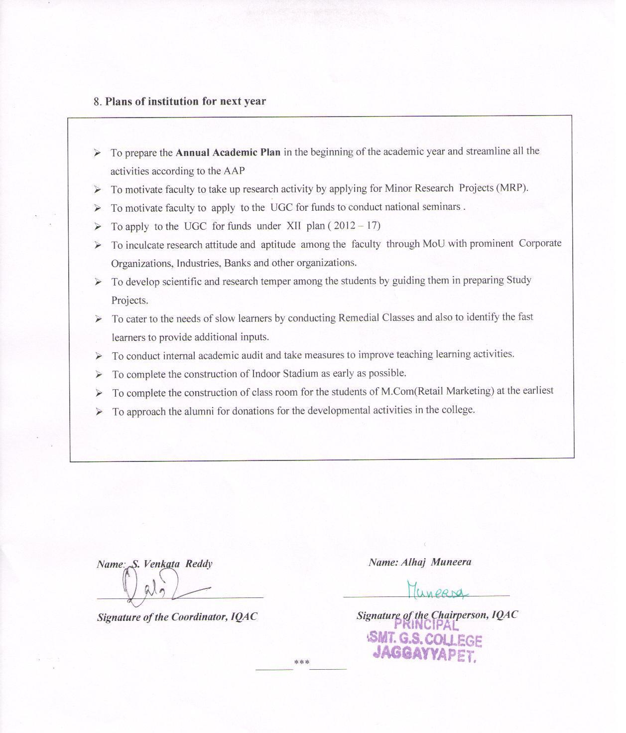

***Annexure –I***

|  |  |  |  |  |
| --- | --- | --- | --- | --- |
| **KRISHNA UNIVERSITY** | | | | |
| **www.krishna university.ac.in** | | | | |
| ***ACADEMIC CALENDER -2013-14*** | | | | |
| ***Particulars*** | ***Date*** | | | |
| ***Class Work*** | ***1st YEAR*** | ***2nd YEAR*** | | ***3rd YEAR*** |
| Commencement of Classes | 10-07-2013 | 03-06-2013 | | 03-06-2013 |
| Closure of a admissions for various courses | 17-08-2013 | | | |
| Closure of Instructions | 15-02-2014 | | | |
| Total Number of working days | 220 | | | |
| ***Examinations*** |  | | | |
| Half Yearly Examinations | 30-09-2013 to 9-10-2013 | | | |
| Pre – final examinations | 20-01-2014 to 30-01-2014 | | | |
| Payment of Examinations fee & Submission of ineligible candidates to the Controller of Examination | 17-10-2013 | | 05-12-2013 | |
| Submission of attendance particulars of ineligible candidates to the Controller of Examination | 20-02-2014 | | | |
| University Theory Examinations | 03-03-2014 | | | |
| Practical Examinations ( English ) | -------------- | | | |
| Practical Examinations ( Others ) | 03-02-2014 | | | |
| **Extra Curricular Activities** |  | | | |
| **Celebrations :** |  | | | |
| Teachers day | 05-09-2013 | | | |
| Education day | 11-11-2013 | | | |
| Voters ‘ day | 25-01-2014 | | | |
| Science day | 28-02-2014 | | | |
| Women ‘s day | 08-03-2014 | | | |
| Earth day | 22-04-2014 | | | |
| **Ragging :** |  | | | |
| Anti – Ragging Committee meeting by all Colleges | 21-08-2013 | | | |
| Fresher’s Day | 24-08-2013 | | | |
| **Cultural :** |  | | | |
| Inter – collegiate Cultural meet | September ,2013 | | | |
| Youth Festival | October ,2013 | | | |
| **Employment :** |  | | | |
| Awareness on employability skills | 1st week of January , 2014 | | | |
| Organizing Centralized Job Fair | 2nd Week of January , 2014 | | | |
| Commencement of Summer Vacation | 01 -04-2014 | | | |

***CURRICULAR PLAN 2013-14***

May 2013 - Preparations for Re –opening of College Cleaning the Campus

Advertisement – City Cable of , JPT, Chillakallu & Kodad

June 2013 - College Re – opening Day.

(04.06.2013) - Preparation of institutional plan

- Preparation of lecturer - wise Annual Curricular Plan - staff meeting to discuss the academic activities - Result Analysis - Commencement of Classes for II & III year students.

July 5th - World Environment Day – Conduct of Related Activities

Anti- Ragging Activities – Organizing Sensitization

Programmes on “ Anti Ragging on Campus

Vanamahosthavam – Tree Plantation activity

Aug .15th - Independence Day Start of unit tests.

Aug.26th - Women’s Equality Day – Conduct of Related Activities by WEC

Aug.29th - Telugu Bhasha Dinosthavam

Sept. 5th - Teachers Day

Sept.8th - International Literacy Day

Sept.22nd - Hindi Divas

Sept.24th - NSS Day

Sept.21st & 22nd - Inter - Collegiate Kabaddi Tournment

Oct. - Principal Evaluation –Collection of feedback from Teachers &

Students and Redressal of Grievances

Oct .2nd - Gandhi Jayanthi & Lal Bahadur Sastri Jayanthi

Oct. 31st - National Integration Day

Nov. 1st - A.P. Formation Day

Nov. 11th - National Education Day

Nov. 14th - World Diabetes Day

Nov.14th -20th - National Library Week

Dec. 2012 - Submission of university exams forms

Dec.1st - World Aids Day

Dec.10th - Human Rights Day

Dec.24th - National Consumer Day

24.12.12 to26.12.12 - Christmas Holidays

Jan.2013 - Conduct of Revision and Remedial classes to needy students

Pre- final Exams – Theory Practicals

Jan.12th - National Youth Day

Jan.25th - National Voters Day

2.01.13. to 20.01.13 - Pongal Holidays

Jan.26th - Republic Day

* College Sports Day

Feb.2014 - Commencement of University Practical Exams

Revision & Remedial Classes to needy students

Feb.21st - Mathru Basha Dinosthavam

Mar.2014 - Commencement of University Theory Exams

Mar.8th - International Women’s Day

***Annexure - II***

**Part B – 1.3 Feedback from Students 2013-2014**

Feedback is collected from the students by respective departments in the month of October, 2014. Feedback forms supplied to the students include 20 items on which students are asked to give their opinion on a Three point rating scale. The 20 items are as hereunder .

1. Efforts to effectively cover 100% of syllabus.
2. The interest generated in the students while teaching in the class room
3. Clarity of expression while teaching the topic/lesson
4. Depth of subject content explained
5. Level of latest developments in the subject taught
6. Use of other methods of teaching like classroom seminar, question - answer, group discussion etc., in the class room
7. Encouraging questions on the topic in the class and clearing doubts
8. Use of various teaching aids in the class room for better explanation of the topic.
9. Quality of synopsis / notes on the topic supplied to the students.
10. Aptitude shown in arranging field visits, guest lectures, study projects etc., in the subject.
11. Encouragement and guidance given to students in reading library (subject and general) books and using internet.
12. Encouragement and guidance given to students in giving classroom seminars.
13. Regularity and seriousness in valuing the answer scripts of monthly tests and discussing the same with students.
14. Remedial coaching and efforts made in preparing the students for University Examinations.
15. Regularity and punctuality to the class
16. Enthusiasm shown to encourage and guide students in curricular, co-curricular , extra-curricular activities and cultural, community services, etc.,
17. Counselling and career guidance
18. Accessibility of the lecturer outside the classroom for academic interaction.
19. Personal care and affection while dealing with individual students and helping students.
20. Overall opinion on the lecturer.

***Analysis on Feedback*:**

The institution has carefully analysed the feedback given by the students and has initiated appropriate measures and made suitable suggestions to the faculty after thorough discussion in the staff meeting.

***Annexure - III***

***Best Practices in the College***

* Effective Adjustment of Classwork.
* Study Hours.
* Tutorial System.
* Ward Counselling .
* Extension / Guest Lectures.
* Science Expo for School Students.
* Organising Knowledge Expo.
* Plantation by NSS and NCC Volunteers.
* Blood Donation by NCC,NSS Volunteers and Other Students.
* Blood Grouping for all Students.
* Field Visits.
* Organising Relief and Rehabilitation Camps Whenever Needed.
* Imparting Employability Skills to the Students.
* Campus Keeping Initiatives / Clean and Green Programmes.
* Anti – Ragging Awareness Programmes .
* Promoting Social Response among the Students
* Organising Cultural Activities.
* Establishment of MoUs with nearby Companies and Organizations.
* Optimum Utilization of UGC Funds.
* Supply of Mineral Water to the Staff as well as Students.
* Distribution of Text Books and Note Books to the Poor Students through Bookbank.
* Extension of Library hours Whenever Needed.
* Payment of College Fees by the Staff for Poor Students.
* Organizing Awareness Programmes for Women Students through Women Empowerment Cell ( WEC )
* Implementation of Swatch Bharat Programme of the Central Government.
* Awareness Programmes for the Students in Matters of Conserving Resources like Water , Trees , Soil, Electricity, Oil , and Pollution Control of all Kinds.
* ***Services by the Dept. of Library Science :***
* Information Display on the Notice Board concerning Employment Opportunities and Further Education.
* Guidance on Entrance Exams and their schedule
* ***Value Based Education***
* Along with curricular , co-curricular and extra – curricular activities, students are given instruction in value based education.
* Extension programmes are organized to instill in the students social and civic responsibilities.
* Personal skills are developed through lectures delivered by experts in their respective fields.
* Measures are taken to enhance confidence of the students to participate in public speaking and cultural activities.
* Instruction on moral education is given through the writings on the walls, charts, maps, pictures , Power Point Presentations etc.
* Now and then guest lectures on spiritual education which is basically aimed at teaching moral values of life are arranged.
* In this direction the affiliating university in consultation with the Commissionnerate of Collegiate Education , has introduced a compulsory paper on value based education entitled as “ Human Values and Professional Ethics “ with a view to making the students responsible and exemplary citizens of the society.

***Annexure - IV***

***Part B- 7.3 Best Practices.***

***1. Payment of Tuition fees & Exam Fees for Poor Students***

**Objectives:**

* To encourage students not to lose the benefits of higher education.
* To motivate the parents of the poor students to send their children to HEIs
* To make the admitted students take their exams and not to avoid Public Exams because of being unable to pay exam fees.

**Needs Identified:**

* Lock of motivation and poverty of parents
* Illiteracy of parents and ignorance of the importance of higher education.
* Financial assistance

**Evidence of Success :**

The faculty & the philanthropists have been supporting the poor and intelligent students in their progression to higher studies . The faculty approach the parents of intelligent but poor students and motivate them to admit their children to the college by assuring them of financial help in respect of tuition fees and exam fees.

**Resources :**

* Funds from faculty , philanthropists and the rich of the town, and the alumni.

**2.** ***Supply of Text Books & Note Books To The Poor Students.***

**Objectives:**

To make students read text books.

To make students get involved in note – taking and note –making.

**Needs Identified :**

Lack of money to buy books.

Lack of interest in Note – Taking & Note –Making

Need for improvement of Study Skills.

**Practice**  :

NSS and NCC students approach philanthropist business firms , voluntary organizations etc. for funds to buy text books and note books. Sometimes UGC funds earmarked for the same purpose are also made use of .

**Evidence of Success** :

Students have improved reading & listening skills. Even rich students who can afford to buy books have bought books and brought them to the classroom. Students have cultivated the habit of taking notes & making notes.

**Resources:**

Funds from faculty, philanthropists and social organizations.