Smt.G.S.College, NAAC-B++,Vidyanagar,Jaggayyapet
Krishna Dist.,Andhra Pradesh

ANNUAL QUALITY ASSURANCE REPORT
2017-2018
Track ID (of Second Cycle): APC0GN -14054

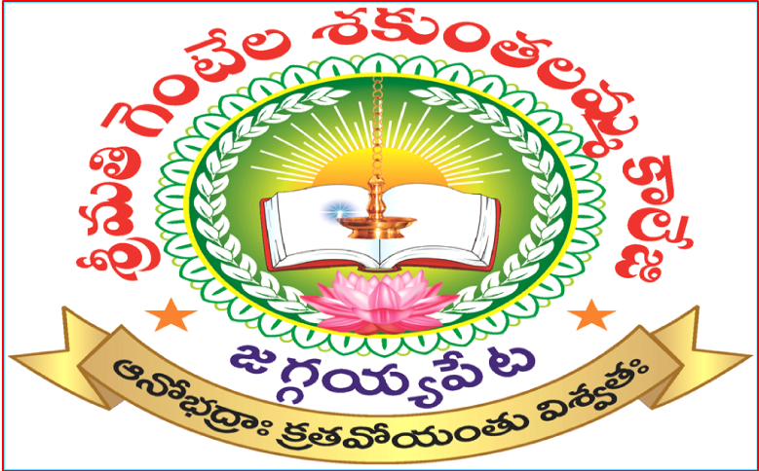

Submitted
To
National Assessment and Accreditation Council
Bangalore

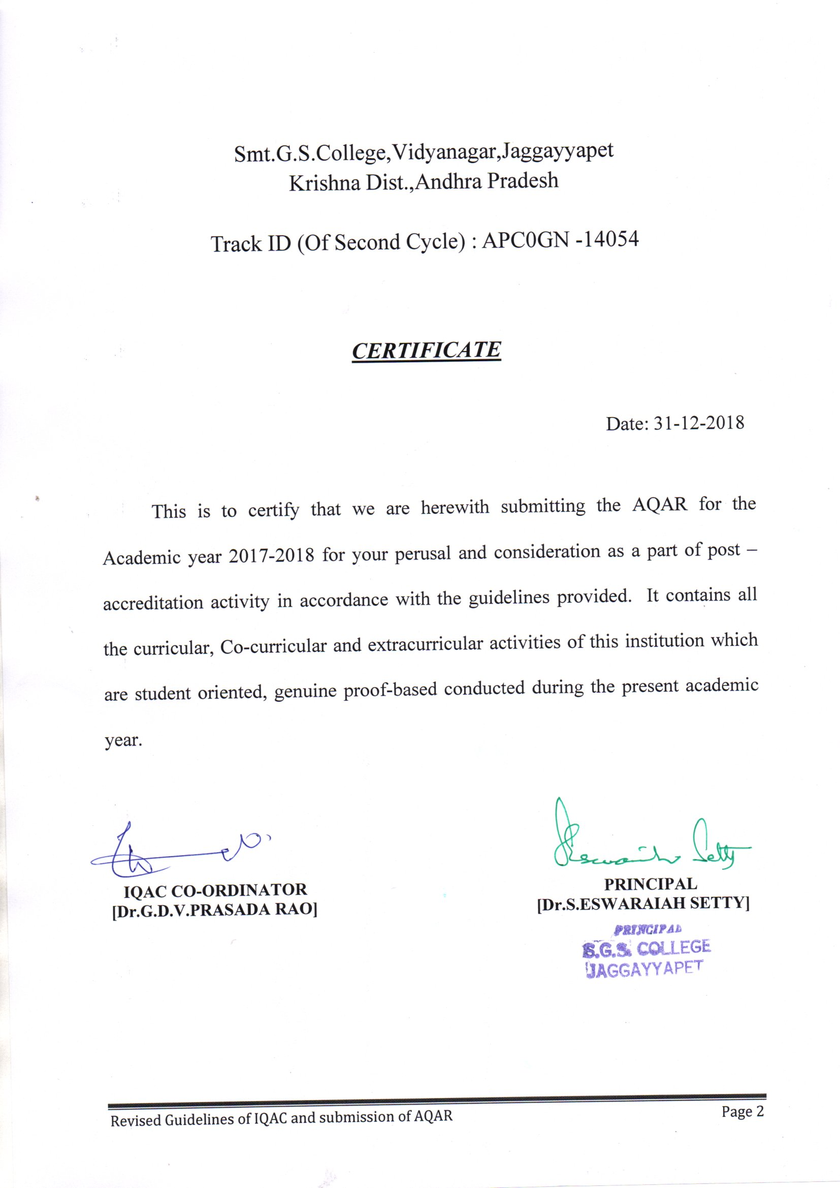

The Annual Quality Assurance Report (AQAR) of the IQAC

Part – A

AQAR for the year
2017-2018

1. Details of the Institution
Smt.G.S. College
1.1 Name of the Institution
1.2 Address Line 1
Vidyanagar
Vijayawada Road
Address Line 2
Jaggayyapet
City/Town
Andhra Pradesh
State
521 175
Pin Code
sgscol.1968@gmail.com
sgscol.1968@yahoo.com

Institution e-mail address
08654 - 222090

Contact Nos.
Dr.S.Eswaraiah Setty
Name of the Head of the
Institution:

08654 - 222090
Tel. No. with STD Code:
9848198988
Mobile:

Name of the IQAC Co-ordinator:
Dr.G.D.V.Prasada Rao
Mobile:
9441715823
sgscol45iqac@gmail.com
IQAC e-mail address:
(of the Second cycle) APCOGN-14054

1.3 NAAC Track ID (For ex. MHCOGN 18879)

1.4 NAAC Executive Committee No. & Date:
F.19.26/EC(SC-26)DO/2017/12.2 Dated 19-07-2017
(For Example EC/32/A&A/143 dated 3-5-2004.
This EC no. is available in the right corner- bottom
of your institution’s Accreditation Certificate)

www.sgscollege.info
1.5 Website address:
http://www.sgscollege.infor/AQAR-2017-2018.doc
Web-link of the AQAR:

For ex. http://www.ladykeanecollege.edu.in/AQAR2012-13.doc
1.6 Accreditation Details
Sl. No. | Cycle | Grade | CGPA | Year of Accreditation | Validity Period
1 | 1st Cycle | B | 2.70 | 2010 | 5 years
2 | 2nd Cycle | B++ | 2.81 | 2017 | 5 years
3 | 3rd Cycle
4 | 4th Cycle

1.7 Date of Establishment of IQAC : DD/MM/YYYY
09/07/2013

1.8 Details of the previous year’s AQAR submitted to NAAC after the latest Assessment and Accreditation by NAAC ((for example AQAR 2010-11submitted to NAAC on 12-10-2011)
- AQAR 2010-11_____________ ____________ (DD/MM/YYYY)
- AQAR 2011-12 submitted to NAAC (20/04/2017)
- AQAR 2012-13 submitted to NAAC (20/04/2017)
- AQAR 2013-14 submitted to NAAC (16/04/2016)
- AQAR 2014-15 submitted to NAAC (16/04/2016)
- AQAR 2015-16 submitted to NAAC (16/04/2016)
- AQAR 2016-17 submitted to NAAC (03/12/2018)
- AQAR 2017-18 submitted to NAAC ()

1.9 Institutional Status
√

University State Central Deemed Private
√

Affiliated College Yes No
√
Constituent College Yes No

√
Autonomous college of UGC Yes No

√
Regulatory Agency approved Institution Yes No
(eg. AICTE, BCI, MCI, PCI, NCI)
√

Type of Institution Co-education Men Women

√
Urban Rural Tribal

√
√
Financial Status Grant-in-aid UGC 2(f) UGC 12B
√
√

Grant-in-aid + Self Financing Totally Self -Financing

1.10 Type of Faculty/Programme
√
√
√

Arts Science Commerce Law PEI (Phys Edu)

TEI (Edu) Engineering Health Science Management

Career Oriented Programmes
Others (Specify)

Krishna University, Machilipatnam

NNal
1.11 Name of the Affiliating University (for the Colleges)
1.12 Special status conferred by Central/ State Government-- UGC/CSIR/DST/DBT/ICMR etc .
NA
Autonomy by State/Central Govt. / University
Nil
University with Potential for Excellence UGC-CPE
Nil
Nil
Nil
DST Star Scheme UGC-CE
Nil
Nil
UGC-Special Assistance Programme DST-FIST
01
NA
UGC-Innovative PG programmes Any other (Specify)
02
UGC-COP Programmes
2. IQAC Composition and Activities
07
2.1 No. of Teachers
01
2.2 No. of Administrative/Technical staff
_
2.3 No. of students
2.4 No. of Management representatives
_
01
2.5 No. of Alumni
2. 6 No. of any other stakeholder and
01
community representatives
02
2.7 No. of Employers/ Industrialists
01
2.8 No. of other External Experts
2.9 Total No. of members
13
06
2.10 No. of IQAC meetings held

06
02
02
2.11 No. of meetings with various stakeholders: No. Faculty
01
02
01
Non-Teaching Staff /Students Alumni Others
√

2.12 Has IQAC received any funding from UGC during the year? Yes No
Rs. 3,00,000/- -
If yes, mention the amount
2.13 Seminars and Conferences (only quality related)
(i) No. of Seminars/Conferences/ Workshops/Symposia organized by the IQAC
13

1
1
11
Total Nos. International National State Institution Level
1.Development of Quality Culture in the Institution
2. Creation of Innovative and Best Practices
(ii) Themes

2.14 Significant Activities and contributions made by IQAC

- Various academic and proficiency prizes were instituted and sponsored by the alumni , members, The Teaching and Non–teaching staff and members of the Management. They were given to the students who scored the highest marks and stood out Meritorious in different subjects in the Public and Semester-End Exams.
- Faculty members are encouraged to help the poor and intelligent students to continue
and not to stop their studies because of financial problems .

- The members of IQAC made it a point to approach the old students, philanthropists , industrial people and lovers of education for developmental activities in the college.

- Compilation of research articles, abstracts and papers presented by the faculty in National and International Seminars and Workshops.

- In order to conduct Internal Academic Audit, a Core Committee, comprising the Principal, IQAC Coordinator, and senior faculty from Science, Commerce and Arts was constituted. The academic audit was held on 27th January, 2015.

External Audit is done by the ‘Academic Audit Team’ deputed by Commissioner of Collegiate Education, Telangana on 28th January, 2015. The members of this Audit Team are Mr. C. V. Ramana Reddy, Asst. Professor, GDC Shadnagar, Mahaboobnagar dist., and Mr. A.V. Ramesh, Asst. Professor, GDC Sathupally, Khammam dist,.
- The IQAC coordinated with Department of Chemistry in organizing National Seminar on the theme – “Recent Trends in Separation Process in Pollution Control” on 12th and 13th of July, 2014. Keynote address in delivered by Dr. S. Sridhar, Principal Scientist – IICT, Hyderabad. Chief Guest for the Seminar Was Sri. Poola Ravinder, MLC. Guests of honor were Prof. P. Vinay Babu, JNTU and Sri. B. Kantha Rao, Secretary – Sri Sai Educational Insitutions, Kodad. This Seminar was a grand success with the active participation of nearly 200 Lecturers and Research Scholars.

- Department of Telugu, in collaboration with Language and Cultural Department, Telangana government, has organized one day ‘State Seminar’ on the topic “Vattikota Alvaru Swamy - Life and Literature” on 6th February, 2015. Keynote address is delivered by famous writer Dr. Nandini Sidha Reddy. Chief Guests for the occasion were Sri. Desapathi Srinivas, OSD Telangana government, and Sri. Venu Sankoju, renowned writer and poet.

- Neil Armstrong said “Research is creating new knowledge”. Our institution pioneered to inculcate scientific temper among the staff and students, and aim the arrows of their inquisitive insight to create new knowledge. The faculty are encouraged to pursue research by submitting their proposals to different funding agencies. Mr. Ch. Rama Raju, Asst. Professor in Botany, has registered for Minor Research Project (MRP) in “Biological control of Fusarium wilt in Brinjal”. Mr. K. Nagi Reddy, Asst. Professor in Chemistry, registered for Minor Research Project (MRP) on the topic – “Reduction in COD level using activated carbon from natural resources: An economical viable solution for industrial, agricultural and domestic purposes”.
- “Ensuring quality higher education is one of the most important things we can do for future generation” said Ron Lewis. To enhance the quality in education each department is provided with fully automated computers to enhance the quality in their academic pursuit, research activities and in fostering innovative teaching – learning process. This academic year printers and internet facility is also provided to all the departments.

- In order to conduct Internal Academic Audit, a Core Committee, comprising the Principal, IQAC Co-ordinator, and senior faculty from Science, Commerce and Arts was constituted. The academic audit was held in the month of December 2017..
External Audit was done by the ‘Academic Audit Team’ deputed by Commissioner of Collegiate Education, Andhra Pradesh on 15 & 16.March, 2018. The members of this Audit Team were Smt. E.Hepsiba, Lecturer in Chemistry, Siddartha College,Vijayawada.
- Sri E.Vara Prasad, Head Department of English, KBN College, Vijayawada
- To enhance the quality in education each department is provided with a pendrive, re–writable CDs & Requisite Facilities to collect store and use the data in their academic pursuit, research activities and in fostering innovative teaching – learning process.
- The IQAC works in collaboration as a team with the CDC and UGC units of the institution to identify the impediments in attaining quality in education and to explore the new schemes and grants for the improvement of quality in education and infrastructure as well.
- The faculty members are encouraged to pursue research in their respective fields of study.
- Faculty members are encouraged to sow the seeds of quest for research in the students by initiating ‘Student Study Projects’. All the departments have been guiding the students on research methodology and encouraging them to prepare Study Projects.
- IQAC maintains good relations with the Alumni association and involves the members in the development of the institution.
- Faculty members of different subjects are encouraged to conduct PG Entrance Coaching for III UG students aspiring to join Post Graduation in different Universities.
- Remedial coaching was conducted for students with backlogs to enhance their learning capabilities and guidance was given to prepare them to fair well in the exams.
- Student feedback was collected very often and positive changes were made in teaching learning activity.
- This year also the IQAC has organized two conferences at the institution level on the following themes : 1. Development of Quality Culture in the Institution 2. Creation of Innovative and Best Practices.

2.15 Plan of Action by IQAC/ Outcome .
The plan of action chalked out by the IQAC in the beginning of the year towards quality enhancement and the outcome achieved by the end of the year *
Plan of Action | Achievements
- EEfforts to get reaccreditated by the NAAC with a handsome Grade  - To prepare Annual Academic Plan in the beginning of the academic year to streamline and co-ordinate all the stakeholders towards the common aim of attaining quality in education.  - The IQAC deems it necessary to co-ordinate with CDC and UGC units of the institution to reach the goal of quality education.  Introduction of Add-On Courses  - To organize National Seminars ,Heads of Departments are enthused to take measures for applying and organizing National or State seminars  - To provide rewards, recognition and incentives to encourage the students to be regular to the college and to put in more efforts in preparing for university exams.  - To conduct Orientation to all the newly admitted students to the college.  - To identify both slow learners and fast learners in each class and to adopt measures to alter the quality of input to be given to them as per their capability.  - To encourage the faculty to use ICT and other innovative practices to enhance teaching-learning process.  - To strengthen ‘Women Empowerment Cell’ and to organize more programmes on gender sensitisation.  - Mentoring of students to be done by making each lecturer the Incharge of 25 students.  - Faculty members are encouraged to show inclination towards research and to apply for MRP from UGC.  - To co-ordinate with Heads of respective departments to organize Student seminars, Department seminars, Guest Lectures and Extension Lectures to augment all round development of the students.  - To conduct remedial classes for the slow learners.  - Faculty are asked to encourage students to take interest in research and prepare a ‘Student study project’(SSP)  - The college magazine has to be maintained giving a window to the staff and students to express their views and exhibit their talents.  - To facilitate wide and practical exposure to the students, it is decided to organize Field trips, Study tours and Industry visit.  - Establishment of training and placement centre on campus in order to provide solid training and lucrative placements to our students.  - To organize ‘Campus Recruitment” by inviting reputed companies to facilitate the students of rural areas to be absorbed into corporate employment.  - To encourage students to participate in sports & games actively to become physically & mentally fit.  .  - To be a Catalist in Strengthening Government owned educational institutions  - Service Activities under the Corporate Social Responsibility (CSR)  - To be a Channel to educate masses about Government Projects & Schemes | - TThe IQAC took every care to ensure that the college stands tall in Providing qualitative and effordable education to students. Under the banner, IQAC several activities were conducted to keep the stage ready for the college to be reaccreditated in its 2nd Cycle. Subsequently, the NAAC Peer Team Visited the College on 14th & 15th July 2017 and rated the college at “B++” with the CGPA of 2.81  - Annual Academic Plan is prepared by the IQAC committee in consultation with all the departments .This Academic Plan is circulated among the departments. Respective departments prepared their own Academic Plan on the basis of the Institutional Academic Plan.  - From the beginning of the academic year the IQAC has conducted meetings with the CDC and UGC units of the institution as and when necessary to identify the impediments in attaining quality in education and to explore the new schemes and grants for the improvement of quality in education and infrastructure as well.  - The IQAC always tries its best to motivate the faculty to apply to the UGC for Minor / Major Projects.  From the Current Academic Year, Certificate Course in Yoga has been introduced with the patronage of Krishna University, Machilipatnam.  Several Crash Courses and Bridge Courses are also pressed into Action for the benfit of Students.  - It also guides and encourages the faculty to prepare and send proposals to the UGC for financial assistance to organise national seminars .  - Various academic and proficiency prizes in the form of books , medals (Gold /Silver ), and cash were instituted by the alumni , members of Teaching and Non-teaching staff and members of Management and they are given to the students who fare well in various subjects and stand first every year.  - All the faculty members conducted orientation to the newly joined students in the first week of July, 2017.  - The faculty, after the I Unit Test have identified and listed out both slow and fast learners of their respective classes. This helped in giving more attention to the slow learners and to give additional inputs to the advanced learners.  - This academic year each department is provided with a pen drive. This facilitated the faculty to collect , store and use the data regarding updating their knowledge and using it in a separate e-class room established to enable faculty to demonstrate using PPT.  - Women Empowerment Cell is functioning effectively in the institution for the past few years. Smt.V.Latha Manga Tayaru is the convener of the WEC . She initiated a couple of programmes to educate the girl students on health, hygiene and legal protections.  - A “ Swatch Bharat “ programme was organised in the college by WEC on  03-08-2017  - WEC Organised “ Anti Ragging Awareness programme ” on 08th Aug -2017. Sri S.Priya Kumar, Sub Inspector of Police Addressed the gathering.  - WEC Organised Bathukamma Dance Competition on the eve of Bathukamma Fest on 25th September,2017. The Winners were given away the Prizes.  - WEC organised an “AIDS awareness Camp on 01st December 2017. Dr.Ayyappa Naidu, Government Hospital, Jaggayyapet, made his presents on the Day.  - Organized Rangoli Competition for Women on 04-01-2018.  - Dr.M.Jayasree, MBBS, Tejasri Hospital, Jaggayyapet & Smt. S.M. Maheswari, Asso.Prof. of English, YN College, Narsapur, Graced the event Organized on the eve of International Women’s Day on 08th March, 2017.  - Through the tutorial system,each faculty is assigned about 20 students. The students who are under the supervision of the faculty, approach their respective mentors for any guidance support and grievance redressal. A separate ‘Complaint Box’ also is placed in the corridor to enable the students to ventilate their grievances.  - Not applied  - Respective departments have conducted Student Seminars for I, II and III year students. Some departments have organized Department Seminars.  - Guest lectures and extension lectures on various topics have been conducted.  - The faculty were motivated and directed to conduct remedial classes for the slow learners as per their convenience and clarify their doubts .  - The faculty members took sincere efforts to encourage students to take up research activities. Student Study Projects were prepared by almost all the Departments .  - It is being brought out every year. Students and staff are contributing their articles to the magazine.  - Normally,the Students of the PG Wing offen take intern ship programmes in various organisations and Bussiness firms to have real time expirence. Respective departments have organized field trips , study tours and industry visits.  - This year the college entered into MOU with Andhra Pradesh State Skill Development Corporation (APSSDC), Vijayawada. The College has also Established a Linkage with Andhra Pradesh Information Technology Academy (APITA), Vijayawada. Through these new linkages the PG and UG students are imparted job oriented training. The mode of training is both on and off line platforms. They are given training in aspects such as communication skills, analytical skills, basics of computer and so on.  - The faculty guides the students for their absorption into employment in various fields on and off campus recruitment drives. The College Origanized Campus a recruitment Drives and helped Students land in Jobs with high potential.  - P.Anupama, III M.COM Got Placed in the HCL Technologies Limited  - A separate slot is provided to help students participate in the sports and games. The Department of Physical Education organizes various games and sports for the students. Our Students actively Participated in Various intra/inter University Tournaments and have won Several laurels to Our College.  - Jwala Narasimha Nayak of III B.Sc Participated in the Rifle Shooting Competition of the 19th NCC Directorate on 18th September,2017.  - P.Dhanush, I CEC Represented our College School National Wait Lifting Competition on 20th September,2017.  - Ajithmiya, III B.COM, & Jagadish, III B.SC, took part in the NCC Trecking Camp Organized at Rajpal, Gujarat on 30th November,2017.  - Organized A Two-Day Inter Collegiate Ball Badminton Tournment for men under the aegis of Krishna University, Machilipatnam.  - Suvarna Raju, of Our College Participated in the All India Ball Badmanton Tournment for men at Yogi Vemana University, Kadapa on 27th December,2017.  - R.Gangadhar, K.Jagadeesh, A.Rajavardhan, Bagged Two Gold Medals & One Silver Medal in the Ash-Te-Do Competition on 11th January,2018.  - B.Gopi Chand Nayak, I B.A., & G.Nikhil, I B.A., took part in the Tennis Ball Cricket Tourney Conducted in SriLanka on 08th March, 2018.  - Under the Flagship banner of Government Educational Institutions Strengthening Association (GEISA), Every year efforts or put in to strengthen Government and Aided Educational Institutions that are the prime source of importing education at different levels to the disadvantaged lot.in this connection, a meet is arranged wherein heads of primary and higher secondary schools of the West Krishna region deliberate with the University Officials and Principals of various colleges that function in the public sector. As a result the Educational Institutions Operating under the Government and Aided wings or getting back their past glory.  - The Benevolent Management has come forward to run a free Hostel for Women from this Academic Year about 50 Merit Students are given free large and boarding facility in the college Hostel.  - During the summer months (April, May & June) the college setup a stall at the APSRTC Bus Station to Provide Cool & Refreshing Mineral Water to the Public.  - The College has become the first source in guiding and educating masses about various projects and schemes launched by the Central and State Governments from time to time.

√

2.15 Whether the AQAR was placed in statutory body Yes No

Management Syndicate Any other body
√
Provide the details of the action taken :

The AQAR was placed before the CDC & Staff Council. It was approved by them. The CDC approved the Annual Action plan in the beginning of the year and permitted the IQAC to implement it.

Part – B
Criterion – I

1. Curricular Aspects
1.1 Details about Academic Programmes

Level of the Programme | Number of existing Programmes | Number of programmes added during the year | Number of self-financing programmes | Number of value added / Career Oriented programmes
PhD
PG | 3 |  | 3
UG | 5 |  | 1 | 2
PG Diploma
Advanced Diploma
Diploma
Certificate
Others-Certificate Course in Yoga |  | 1
Total | 8 | 1 | 4 | 2
Interdisciplinary
Innovative

1.2 (i) Flexibility of the Curriculum: CBCS/Core/Elective option / Open options
(ii) Pattern of programmes:

Pattern | Number of programmes
Semester | 08
Trimester | -
Annual | -

1.3 Feedback from stakeholders* Alumni Parents Employers Students
√

√

√
(On all aspects)

√

Mode of feedback : Online Manual Co-operating schools (for PEI)
*Please provide an analysis of the feedback in the Annexure

1.4 Whether there is any revision/update of regulation or syllabi, if yes, mention their
Salient aspects.

Syllabi and curricula are followed as designed by the affiliating university, that is, Krishna University, Machilipatnam . From this academicyear the university has restructured all the U.G.Courses. It has introduced Choice Based Credit System(CBCS) with semester pattern it has introduced ten foundation courses to help the students have the knowledge of various basic and very essential concepts bundled with the regular U.G.programmes. The fundamental concepts are taken from various emerging areas such as 1. Human values and Professional ethics 2. Environmental science 3.Information and Cumminication Technolony (ICT) 4. Communication and Soft Sklills (CSS I,II,III) 5. Analytical Skills 6.Leadership Qualities 7.Entrapenurship.
The University Introduced Cluster Subjects in the 6th Semester at the UG Level in order to give Students an Opportunity to Study Subjects of their Choice and Design their Carrier Accordingly.

.

1.5 Any new Department/Centre introduced during the year. If yes, give details.
Yes,with the aegis of Andhra Pradesh Information Technology Academy (APITA), Vijayawada, A Skill Development and Placement Center has been established to impart employability skills to our students. With this new initiative, the college provides on line and off line trainings to students and helps them get employed in Various Companies and Organizations.

Criterion – II
2. Teaching, Learning and Evaluation
2.1 Total No. of permanent faculty
Total | Asst. Professors | Associate Professors | Professors | Others
13 | 3 | 10

02
2.2 No. of permanent faculty with Ph.D.

2.3 No. of Faculty Positions
Asst. Professors |  | Associate Professors |  | Professors |  | Others |  | Total
R | V | R | V | R | V | R | V | R | V
 | 25 |  |  |  |  |  |  |  | 25
Recruited (R) and Vacant
(V) during the year

2.4 No. of Guest and Visiting faculty and Temporary faculty

25

2.5 Faculty participation in conferences and symposia:

No. of Faculty | International level | National level | State level
Attended Seminars/ Workshops |  | 5 | 2
Presented papers |  | 5 | 2
Resource Persons

  - Innovative processes adopted by the institution in Teaching and Learning:

- The faculty encourages students to work hard and study well to bag academic and proficiency prizes ( Books, Gold /Silver medals , cash prizes etc.)
- The papers and articles presented by the faculty in different State, National, and International Seminars are compiled.
- To facilitate wide and practical exposure to the students, it is decided to organize Field trips, Study tours and Industry visits. Departments of Botany, Zoology,Physics, Chemistry , Commerce and History have organized field trips to Krishi Vignan Kendram – Garikapadu ,Rachem Industries, Mukthyala ,Ramco Cements Pvt. Ltd.,Jayanthipuram , Big Bazaar Vijayawada, Pulichinthala Project , Cashewnut Unit, Autonagar, Jaggayyapet, Amoda Spintex, X Road, Jaggayyapet, Coca-Cola India Pvt. Ltd, Atmakuru Unit, Guntur District Extra. .
- Career Guidance Cell of our institution takes keen interest in building the confidence among the students in practicing Spoken English and also equipped them with Personality Development skills and Soft skills. Every year the CGC takes initiative to organize ‘on and off Campus Job Drives’.
- For PG students two hours on Saturdays are earmarked for importing training on finishing skills. The Director, PG Studies organizes a guest / extension lecture on subject – related to career options, career guidance, personality development, communication and soft skills and any topic of interest to student growth.

2.7 Total No. of actual teaching days during this academic year
175

2.8 Examination/ Evaluation Reforms initiated by
NA
the Institution (for example: Open Book Examination, Bar Coding,
Double Valuation, Photocopy, Online Multiple Choice Questions)

7
7 22
7
2.9 No. of faculty members involved in curriculum
restructuring/revision/syllabus development
as member of Board of Study/Faculty/Curriculum Development workshop
85%
2.10 Average percentage of attendance of students

2.11 Course/Programme wise
distribution of pass percentage : (2016-17)

Title of the Programme | Total no. of students appeared | Division
Title of the Programme | Total no. of students appeared | Distinction % | I % | II % | III % | Pass %
B.A III | 6 | 1 |  | 3 |  | 67
B.Com III | 27 | 2 | 1 | 3 |  | 22
B.Sc III | 27 | 4 | 3 | 11 |  | 67
M.Sc (Physics) | 21 | 3 | 1 |  |  | 19
M.Sc  (Chemistry ) | 29 | 10 | 3 |  |  | 45
M.Com (Retail Marketing) | 26 | 19 | - |  |  | 73

2.12. How does IQAC Contribute/Monitor/Evaluate the Teaching & Learning processes
The IQAC prepares the Annual Academic Plan incorporating curricular, co-curricular and extra-curricular activities in the beginning of the academic year itself. The IQAC co-ordinates its activities with CDC and other units of the institution. It takes measures to identify both slow and fast learners in each class after the 1st Unit test. On the basis of this evaluation the faculty alters their teaching learning processes. The Heads of all the Departments submit their departmental reports to the IQAC, on the basis of which remedial measures are taken. Feedback from the students, parents and other stakeholders are obtained at regular intervals.

2.13 Initiatives undertaken towards faculty development
Faculty / Staff Development Programmes | Number of faculty  benefitted
Refresher courses | -
UGC – Faculty Improvement Programme | -
HRD programmes | -
Orientation programmes | -
Faculty exchange programme | -
Staff training conducted by the university | 2
Staff training conducted by other institutions | 2
Summer / Winter schools, Workshops, etc. | -
Others | -

2.14. Details of Administrative and Technical staff
Category | Number of Permanent  Employees | Number of Vacant  Positions | Number of permanent positions filled during the Year | Number of positions filled temporarily
Administrative Staff | 16 | 18 | - | 8
Technical Staff | 2 | 2 | - | 4

Criterion – III
3. Research, Consultancy and Extension
3.1 Initiatives of the IQAC in Sensitizing/Promoting Research Climate in the institution
The IQAC has taken keen interest in promoting research aptitude among the teachers and the taught of the college. The faculty are encouraged to pursue research activities. For this purpose latest research equipment is provided in all science laboratories. The central library has the facility of INFLIBNET. Latest Reference Books and Journals are made available to all the faculty. The students are also encouraged to develop fascination towards research. They are motivated to prepare Student Study Projects. Field visits and educational tours are organized for the students. Visits to industries, research centres are arranged to ignite the spirit of enquiry among them. Science students are motivated to maintain the botanical garden by themselves to give them a practical exposure to different species of plants. Social sciences students are encouraged to take up social surveys to become aware of the methods of data collection.

3.2 Details regarding major projects
 | Completed | Ongoing | Sanctioned | Submitted
Number | - | - | - | -
Outlay in Rs. Lakhs | - | - | - | -

3.3 Details regarding minor projects
 | Completed | Ongoing | Sanctioned | Submitted
Number | _ | _ | - | -
Outlay in Rs. Lakhs | _ | _ | - | -

3.4 Details on research publications
 | International | National | Others
Peer Review Journals | 01 | _ | -
Non-Peer Review Journals | - | _ | 01
e-Journals | - | _ | -
Conference proceedings | - | 2 | -

3.5 Details on Impact factor of publications:
-
-
-
-
Range Average h-index Nos. in SCOPUS

3.6 Research funds sanctioned and received from various funding agencies, industry and
other organisations

Nature of the Project | Duration  Year | Name of the  funding Agency | Total grant  sanctioned | Received
Major projects | - | - | - | -
Minor Projects | _ | _ | _ | _
Interdisciplinary Projects | - | - | - | -
Industry sponsored | _ | - | - | -
Projects sponsored by the University/ College | _ | - | - | -
Students research projects  (other than compulsory by the University) | - | - | - | -
Any other(Specify) | - | - | - | -
Total | _ | _ | _ | _

3.7 No. of books published i) With ISBN No. Chapters in Edited Books
3
-
02
ii) Without ISBN No.

3.8 No. of University Departments receiving funds from
-
-
UGC-SAP CAS DST-FIST
-
-
-
DPE DBT Scheme/funds

3.9 For colleges Autonomy CPE DBT Star Scheme
-
-
-
INSPIRE CE Any Other (specify)
-
-
-

_
3.10 Revenue generated through consultancy

Level | International | National | State | University | College
Number | - | 02 | 01 | - | 20
Sponsoring agencies | - | Self-finance | Self-finance | - | Self-finance
3.11 No. of conferences organized by the Institution
02
3.12 No. of faculty served as experts, chairpersons or resource persons
--
--
05
3.13 No. of collaborations International National Any other
06
3.14 No. of linkages created during this year

3.15 Total budget for research for current year in lakhs : Nil
-
-
From Funding agency From Management of University/College
Total
-

3.16 No. of patents received this year
Type of Patent |  | Number
National | Applied | -
National | Granted | -
International | Applied | -
International | Granted | -
Commercialised | Applied | -
Commercialised | Granted | -

3.17 No. of research awards/ recognitions received by faculty and research fellows
Of the institute in the year
Total | International | National | State | University | Dist | College
1 | - | - | 1 | - | - | -

3.18 No. of faculty from the Institution
1
who are Ph. D. Guides
and students registered under them
NIL
NIL
3.19 No. of Ph.D. awarded by faculty from the Institution

3.20 No. of Research scholars receiving the Fellowships (Newly enrolled + existing ones)
--
--
--
--
JRF SRF Project Fellows Any other

3.21 No. of students Participated in NSS events:
100
-
University level State level
-
-
National level International level

3.22 No. of students participated in NCC events:
-
-
University level State level
3
-
National level International level
3.23 No. of Awards won in NSS:
-
-
University level State level
-
-
National level International level
3.24 No. of Awards won in NCC: University level State level

-
-
-
National level International level
3.25 No. of Extension activities organized
-
2
University forum College forum
2
3
NCC NSS Any other
2

3.26 Major Activities during the year in the sphere of extension activities and
Institutional Social Responsibility

- Our institution has a vast campus area of nearly 14.72 acres of land. Just like every year this year also the management of the college has permitted religious communities to organize their religious meets.
- Our institution is proud to provide platform to the people of different walks of life and working in different sectors in and around Jaggayyapet to conduct various programmes , meetings , functions etc. It has taken keen interest in building the confidence among the students in practicing Spoken English and also equipped them with Personality Development skills and Soft skills.
- Department of Zoology organized ‘Blood Grouping Camp’ for the students and the staff .
- Ist December 2017 Aids Rally was taken up in the town
- In order to strengthen the educational institutes functioning under government and aided banner, a separate body was constituted with representatitve members from both college and government schools. It was named as Government Educational Institutions Strengthening Association (GEISA) which was setup to address the needs of students studying in Government/Aided Colleges/Schools.

- The institution is privileged to have NSS & NCC units. NSS Special Camp was organized from 7th to 13th January, 2018 at Dharmavarapupadu Thanda village. Students are enlightened on the issues of social responsibility, environment protection, gender sensitivity etc.
- Department of Political Science has organized an extension lecture on The Importance of Voters Enrolment on 25th January, 2018.

- On 18^{h} December, 2017, Campus Recruitment Drive was Organized and many students got placed in various organisations with high repute..
- Besides education, the institution has made sincere efforts to provide Career Guidance not only to our students but even to other aspirants, enlightening them about the newly emerging employment opportunities.

- Massive Plantation programme was taken up by planting nearly 500 plants in and around the campus area.

- In General, NCC and NSS wings extend their services round the year as and when necessary in the matters of Town Traffic Control and Bandobusth at the places of worship on festive occasions.
- New turf of grass was laid in the main Campus and in appropriate places to enhance greenery and make the campus an exotic spot.

- The Benevolent Management has come forward to run a free Hostel for Women from this Academic Year about 50 Merit Students are given free large and boarding facility in the college Hostel.
- During the summer months (April, May & June) the college setup a stall at the APSRTC Bus Station to Provide Cool & Refreshing Mineral Water to the Public.
- The College has become the first source in guiding and educating masses about various projects and schemes launched by the Central and State Governments from time to time.

Criterion – IV
4. Infrastructure and Learning Resources
4.1 Details of increase in infrastructure facilities:
Facilities | Existing | Newly created | Source of Fund | Total
Campus area | 14.72 | - | - | -
Class rooms | 24
Laboratories | 14 | -
Seminar Halls | 1 | - | - | -
No. of important equipments purchased  (≥ 1-0 lakh) during the current year. |  | 17
Value of the equipment purchased during the year (Rs. in Lakhs) |  | 22819
Others

4.2 Computerization of administration and library
Administration is fully computerised. There are 03 computers with internet facility. 75% of Library is also automated. Library is equipped with 03 computers with internet facility and INFLIB NET.

4.3 Library services:
 | Existing |  | Newly added |  | Total
 | No. | Value | No. | Value | No. | Value
Text Books | 27180 | 1013904 | 5 | 4448 | 27185 | 1018352
Reference Books | 2401 | 250858 | - | - | 2401 | 250858
e-Books | - | - | - | - | - | -
Journals | 1930 | 190571 | 10 | 10649 | 1940 | 201220
e-Journals | - | - | - | - | - | -
Digital Database | - | - | - | - | - | -
CD & Video | 50 | 3500 | - | - | 50 | 3500
Others (specify) Vinar Racks ,News Papers | 35 | 164495 | 1.Soul Premium member ship fee 2. INFLIBNET Annual member ship fee  3.News papers -8 | 12000 6000 8195 |  | 190690

4.4 Technology up gradation (overall)
 | Total  Computers | Tabs | laptops | Computer  Labs | Internet | Browsing Centres | Computer Centres | Office | Departments | Others
Existing | 50 |  |  | 1 | 6 | 1 | 1 | 3 | 4
Added | 12 | 30 | 30 |  |  |  |  |  |  | Printer-1  Pac-1  Wallmount Speaker -2  Amplifier-1  Router-1  Wifi Router-1  Wifi Hotspot-2  Led TV-2  Solar Power Backup -1  CC Cameras – 4  Video Recorder-1
Total | 62 | 30 | 30 | 1 | 6 | 1 | 1 | 3 | 4 | 17

4.5 Computer, Internet access, training to teachers and students and any other programme for technology upgradation (Networking, e-Governance etc.)

Our institution provides computers with internet access to faculty and students. Library is fully automated with 03 computers with internet facility. INFLIBNET is also subscribed by the institution. Every year training in basic computer skills is imparted to faculty and also to non-teaching staff.

4.6 Amount spent on maintenance in lakhs :
13852
i) ICT
1679656
ii) Campus Infrastructure and facilities

39000
iii) Equipments
370000
iv) Others

2102508
Total :

Criterion – V
5. Student Support and Progression
5.1 Contribution of IQAC in enhancing awareness about Student Support Services

- The IQAC helped the students to have easy access to all the relevant information regarding admission procedure, syllabus, examination pattern etc., by certain devices like
  - Notice Board
  - College Brochure
  - Pamphlets
  - Periodic Press releases
  - Siti Cable
  - Mentoring System is adopted to give personal counselling to the students by Faculty to minimize dropout rate in the college.
- Every Semester student feedback is collected from the students , and the opinion of the students is consolidated by the IQAC. Remedial measures are designed on the basis of the feedback given by students.
- The institution publishes its updated prospectus, Magazines and handbooks annually, annual calanders. All the requisite information is disseminated to students at the beginning of every academic year.
- Each department of the institution takes keen interest to conduct Elocution Competitions, Debates, Class room Seminars, Quizzes and Group Discussions to enhance the communicative and analytical Skills among the students.
- Special measures are taken to enhance Personality Development and Soft Skills among the students coming from rural background.
- A Skill Development center was setup with the support of Andhra Pradesh State Skill Development Corporation (APSSDC), Vijayawada and Andhra Pradesh Information Technology Academy (APITA), Vijayawada to offer online and offline training programmes to students to hone up their skills.
- A Campus Recruitment Drive was organised to provide on campus and off campus placements to the educated un-employed youth.

5.2 Efforts made by the institution for tracking the progression
- The institution is maintaining its contact with the previous students through college website, Whatsapp, and also its Social Networking site.
- Each department maintains an ‘Alumni Record’ consisting of the particulars of outgoing students.
- Alumni meetings are convened at least twice a year. A separate register is maintained to compile the particulars of the ex-students of the college.
- Sometimes accidental meetings of the faculty with the old students at functions, social gatherings, on certain important occasions etc give a scope for tracking the progression of the alumni. The Alumni association is motivated to contribute generously for the development of the institution.
- The Alumni association is motivated to contribute generously for the development of the institution.

5.3 (a) Total Number of students
UG | PG | Ph. D. | Others
278 | 178 | -- | 16

Nil
(b) No. of students outside the state
Nil
(c) No. of international students

Men Women
No | %
286 | 63
No | %
170 | 37

Last Year |  |  |  |  |  | This Year
General | SC | ST | OBC | Physically Challenged | Total | General | SC | ST | OBC | Physically Challenged | Total
59 | 194 | 34 | 186 | 1 | 473 | 44 | 193 | 32 | 187 | 1 | 456

Demand ratio 1:12 Dropout : 06%
5.4 Details of student support mechanism for coaching for competitive examinations
( If any)

- Besides regular instruction in curricular and co-curricular activities Career Guidance is offered to the students enlightening them about the newly emerging employment opportunities. Free coaching for Competitive exams like Group IV and Constables was conducted by the faculty for the college students and outsiders. Couple of departments have conducted PG Entrance Coaching.
- Career Guidance Cell of the institution always tries to be conversant about the syllabi and examination patterns for competitive exams. It gives proper guidance to the students regarding the newly emerging employment opportunities, patterns of entrance exam and the syllabi for such exams.

90
No. of students beneficiaries

5.5 No. of students qualified in these examinations
-
-
-
-
NET SET/SLET GATE CAT
IAS/IPS etc State PSC UPSC Others
-
-
-
-

5.6 Details of student counselling and career guidance

- Faculty members are given the responsibility of about 25 students each under the programme of Ward Counselling. Career Guidance Cell of our institution takes keen interest in building the confidence among the students in practicing Spoken English and also conducts classes on Personality Development and Soft skills.
- With a view to providing intensive training in employability skills and help our students get employed in various Companies, the college established a skill development center on campus. Such a center was set up with the help of Andhra Pradesh State Skill Development Corporation (APSSDC),Vijayawada, & Andhra Pradesh Information Technology Academy (APITA), Vijayawada. The new initiative as been very fruitfull.
- With the auspices of the Andhra Pradesh State Skill Development Corporation (APSSDC),Vijayawada & Andhra Pradesh Information Technology Academy (APITA), Vijayawada. Campus Recruitment Drive.

ABOUT 90
200

No. of students benefitted
5.7 Details of campus placement
On campus |  |  | Off Campus
Number of Organizations Visited | Number of Students Participated | Number of Students Placed | Number of Students Placed
3 | 100 | 20 | 70

5.8 Details of gender sensitization programmes
The institution has Anti-ragging Committee and Women Empowerment Cell. These two committees will take care of girl students of the institutions and their problems. Several activities and expert talks were conducted to sensitise students in matters concerning gender issues.

5.9 Students Activities
5.9.1 No. of students participated in Sports, Games and other events
73

10
2
State/ University level National level International level

No. of students participated in cultural events
20
Nil

Nil

State/ University level National level International level

5.9.2 No. of medals /awards won by students in Sports, Games and other events
3
-
Sports : State/ University level National level International level
Nil
1
Nil

Nil

Nil

Cultural: State/ University level National level International level

5.10 Scholarships and Financial Support
 | Number of  students | Amount
Financial support from institution (Free Hostel for Meritorious Women wards ) | 50 | 500000
Financial support from government | 456 | 3498492
Number of students who received International/ National recognitions | Nil | Nil

5.11 Student organised / initiatives
Nil

Nil

Nil

Fairs : State/ University level National level International level
Nil

Nil

Nil

Exhibition: State/ University level National level International level

5.12 No. of social initiatives undertaken by the students
03

5.13 Major grievances of students (if any) redressed:

- Payment of tuition fees for students who are not able to pay.
- APSRTC Bus Passes.
- Payment of Public Examination fees
- The system of mentorship and ward counselling are being effectively managed in the college. As a result,many grievances faced by students are redress immediately.

- Issues concerning women students are attended to by all the women staff under the supervision of Senior women faculty. Time to time, basic amenities are being improved to ensure that their are enough safety, security and hygienic conditions in the college.
Most of the faculty members are always prepared to redress the above problems. Sometimes they also pay for the fees of entrance exams for those students who are going for PG Studies.

Criterion – VI
6. Governance, Leadership and Management
6.1 State the Vision and Mission of the institution
Vision:
To cater to the higher educational needs of the rural youth in this undeveloped region in the West Krishna and make them globally acceptable, competitive and employable.
Mission :
- To impart affordable education in Arts, Commerce and Sciences in this rural and backward area to all the marginalized sections of the society.
- Dissemination of knowledge and establishment of knowledge society.
- Inculcating a value system among students and making them responsible future citizens of the country.

6.2 Does the Institution have a Management Information System
The Institution has a Management Information System. Information about any activity in the college is made readily available for anybody who seeks information for a genuine cause or purpose.
- Principal is the Appellate Authority.
- Vice – principal is the Public Information Officer
- Office Incharge is the Asst. Public Information Officer.

6.3 Quality improvement strategies adopted by the institution for each of the following
6.3.1 Curriculum Development
The institution is affiliated to Krishna University, Machilipatnam. The affiliating university designs and prescribes the curriculum . The affiliated colleges follow it and prepare the Annual action plan dept. wise in the very beginning of the academic year. Many Senior Faculty of our college or sharing and or the Active members of the Board of Studies (BOS) of the affiliating University whose suggestions the University Curricula is designed and implemented.

To enrich the curriculum and make it more effective, the institution conducts co-curricular and extra - curricular like guest-lectures, extension-lectures, field trips, group discussions, mock interviews, students’ visits to industries, personality development activities, communication skills, marketing and managerial skills and the like to educate the stakeholders on matters of employment and job-orientation. It also introduces additional inputs, and other modules to make teaching - learning activities purposeful and more interesting .

From this Academic year , a new Certificate course in Yoga has been introduced.

To provide Training to Students on Technical Courses the College tied up with the Andhra Pradesh Information Technology Academy (APITA), Vijayawada.

6.3.2 Teaching and Learning
Teaching and learning activities go hand in hand .Though the students joining this institution are with poor educational background & standards, the faculty are doing their best to give them quality education and required skills.

The members of the faculty adopt various methods as demanded in their classrooms for teaching. They motivate students to take up classroom seminars, study projects and assignments to assimilate the subject matter in their learning. They use group work, pair work, and individual study methods to learn in a better way.

The quality of teaching and learning is evaluated periodically by the HoDs of respective departments. The institution under the supervision of the Principal collects the feedback from the students about teaching-learning quality imparted by the institution. The quality of learning is evaluated by unit tests, mid exams, terminal exams and annual exams results.

The college has a well established central library with over 30,000 valumes, Scores of Journals, Periodicals, Dailys and so on. Each Department has its own library to benefit the students. Students are increased to make use of the resources of the libraries and get educational benefit. The college also provides free internet facility to help students have excess to the latest information from various online resources. The college also has the ICT facilities which inhances the process of teaching and learning on the real time basis.

Each department maintaince a list of previous year question papers of their respective subjects and issues them to students upon request. Such a practice femiliarises the students with the scheme and pattern of sem & exams and helps them to fairwell in those exams.

6.3.3 Examination and Evaluation
There are two types of exams - internal and external. Internal exams are conducted periodically and answers scripts are valued and marks are recorded in the Home Marks Register. Based on these marks academic prizes will be given to the high scorers . External exam, that is , sem.- end exams are conducted by the affiliating university and in the stipulated time ,results are given on the university website.
The institution follows the process of evaluation prescribed by the affiliating university. It follows the rules and regulations notified to the institution without fail.
The Principal and the Heads of Departments make an analysis of the performance of the students in the exams. Each Department maintains a separate Marks Register and the faculty concerned also make an analysis of the performance of students .
The assessment and evaluation regarding the All Round Development of the students is also done by the respective departments. Students are awarded various medals , cash prizes and other incentives to encourage them to do still better.
The IQAC and its members closely supervise the process of examination and evaluation.

6.3.4 Research and Development
Research is a very significant activity in any higher educational Institution. Hence the members of the faculty are encouraged to do research in their own fields by using the existing library facilities.
Students are also involved in study projects and project works and thus inspired to develop research aptitude.
Our institution is privileged to have 02 faculty members with Ph.D, and 05 with M.Phil. Presently 04 faculty members have been pursuing their Ph.D.
Students are increased to take up study projects in order to enhance their quest for research. T
They are also given ample scope to prepare research papers on various topics and present them in their class rooms. A few students evince interest and participate in various national and regional seminars and workshops organised in different places. Through field trips and internships students develop experiential learning which instils the spirit of inquiry in them.

6.3.5 Library, ICT and physical infrastructure / instrumentation
The institution is a government aided college. The management of the college takes care of all the Infrastructural facilities required in the institution with its own funds and with the funds received from the Government as well as from the UGC.
The institution has a well stocked and furnished Centre Library besides departmental libraries. There is also an ICT facility.
The members of the Management and the Faculty always put in their best efforts to develop the institution in all its aspects to give quality education to the stake holders. They approach the alumni , philanthropists , social organizations and lovers of education to mobilize the funds for the development of the college.
The following table shows the particulars of donations raised by the institution in this academic
year for the development of infrastructure and other developmental activities.

Sl.No | Donor | Amount | Purpose | Cash/Kind
1 | Bright future Rural Development Society ( Rev.P.Prabhudas Vice-President, SGS College Committee) | 50000 | College  development | Cash
2 | New Hope Ministries, Chillakallu, ( Rev.P.Prabhudas Vice-President, SGS College Committee) | 50000 | College  development | Cash
3 | Sri Chintha Venkata Seshanandam, Treasurer SGS College Committe | 200000 | College  development | Cash
4 | Sri Upputholla Kondala Rao, Amoda Industries, CMD | 600000 | College development | Cash
5 | In Memory of Rangapuram Ramulu, Wife Lakshmibai & Sons (Rangapuram Narasimharao & Brothers) | 100000 | College development | Cash
6 | Sri Bathula Srinivasa Rao (Lighting House) | 50000 | College development | Cash
7 | Sri Yedukondalu (Stage Decoration) | 50000 | College development | Cash
8 | Sri Annapureddy Durga Prasad S/o Yedukondalu (Tent House) | 50000 | College development | Cash

Presently the institution has 30 class rooms, 20 laboratories, 01 Seminar hall cum
E-class room, 01 Computer lab and 01 English Language Lab.

6.3.6 Human Resource Management

The Human Resource Management is very important for any Institution / Organization. This Institution is being run by the S.G.S. College Committee which consists of the General Body and the Governing Body. The Principal , the Head of the Institution, Teaching Staff and Non - Teaching Staff and the Support Staff discharge their duties to the best of their ability obeying the management and implementing the rules and regulations of the Government and the affiliating the university.
- Faculty are required to shoulder the responsibilities like IQAC, NAAC, UGC, RUSA 2.0, CDC , Sports, NSS, NCC , Fine Arts etc.
- In this institution there are 3 types of staff – aided staff, unaided staff and part- time staff to handle all the classes and teach the subjects.
- Teachers are given additional charges for various extra-curricular and co- curricular activities.
- Staff Council Meetings are held periodically in the principal’s chamber to bring co-ordination among the convenors of various committees and review the activities.

6.3.7 Faculty and Staff recruitment

In the aided colleges the faculty and staff recruitment will be done by the Recruitment Committee consisting of five members by following the procedure of selection prescribed by the Government. One of them will be a representative of the Government. The Selection Committee select the members of faculty and staff and send the list of selected candidates for the approval of the Government. Generally the Government approve of the selected candidates and release the grant towards their salaries after admitting them to grant-in- aid. This is the normal procedure.
Right now the Govt. Of A.P. is not in favour of staff recruitment in aided colleges. If the aided staff member retires & the post falls vacant, the Govt . doesn’t come forward to fill up that post. The burden rests with the college Management. If they are able to bear the salary component , they will appoint a member on the part – time basis with a very – low pay.

6.3.8 Industry Interaction / Collaboration
At the college level and at the departments level, we have established linkages / collaborations with certain colleges, organisations, universities and industries .
Almost all the departments of the college has established linkages with K.V.R. College , Nandigama & K.R.R. College , Kodad. Departments of Chemistry & Physics are in collaboration with Ramco Cements Ltd. Jayanthi Puram & Rachem Industries , Mukthyala
Departments of Botany & Zoology have had tie – ups with Krushi Vignana Kendra, Garikapadu.
Some of the departments have linkages with their counterparts in Krishna University, Machilipatanam and Acharya Nagarjuna University, Guntur.
Especially the Department of Telugu has established linkages with more than ten colleges in the state.
At the college level, the college has entered in to an M.o.U. with Andhra Pradesh State Skill Development Corporation (APSSDC),Vijayawada & Andhra Pradesh Information Technology Academy (APITA), Vijayawada to offer training and placements to students.

6.3.9 Admission of Students

Admission process is totally based on the rules and regulations of the Govt. and affiliating university . Reservations are followed. Strict transparency and admission rules are adhered to by the College. No student is denied an admission.
The admission rules and schedule is displayed on the notice board, published in local news papers, telecast in local TV channels and displayed on the institution Website, Pamplets are distributed, posters are pasted on the walls in important localities and inter-institutional activities are conducted to draw the attenction of prospective students and their parents and seek admission into the college.
Social Networking platforms are also used to promote admissions.

6.4 Welfare schemes for
Teaching | - SGS College Staff Credit Society & SGSC Co- operative Society are established to resolve financial problems related to various problems of the members.  SGS College Teaching Staff Association plays an active role in handling issues concerning the teaching staff from time to time. Perodic meetings are conducted to address the needs of the faculty.  - To Adress needs and grievances of women staff, Women Empowerment cell as been established which functions very actively  - To regularise the posts of un-aided and part time faculty working against aided vacancies, time to time, several activities are planed to voice their feelings so as to communicate their just demands to the government in order to help them get absorved..  - The college has a gym of its own. This ensures the health, fitness & wellness of our staff.  - The staff are also encouraged to participate in sports & games meet of the college.  - The college management recorgnises the services of hits staff and honours them on special occations. On the eve of teachers day on 15th septmber every year it felicitates the retiree during that particular academic year. This has really encouraged and motivated the staff to perform well over a period of time.
Non teaching | - SGS College Staff Credit Society & SGSC Co- operative Society  are established to resolve financial problems related to various problems of the members  SGS College Non-Teaching Staff Association plays an active role in handling issues concerning the teaching staff from time to time. Perodic meetings are conducted to address the needs of the Non-Teaching Staff.
Students | - Awards instituted by central & State Governments  - Book Bank facility  - Scholarships and Cash Awards  instituted by local people as well as faculty  - Financial aid extended to needy students by the philanthropists.

6.5 Total corpus fund generated
50 Lakhs

NOOOO
6.6 Whether annual financial audit has been done Yes No

6.7 Whether Academic and Administrative Audit (AAA) has been done?
Audit Type | External |  | Internal
Audit Type | Yes/No | Agency | Yes/No | Authority
Academic | Yes | CCE | Yes | IQAC
Administrative | No | - | Yes | Management

6.8 Does the University/ Autonomous College declares results within 30 days?
√

-
For UG Programmes Yes No
√

-
For PG Programmes Yes No

6.9 What efforts are made by the University/ Autonomous College for Examination Reforms?
Admission process, Curriculum and Exams are followed strictly according to the norms of the affiliating University. The institution has no autonomy in making any changes to this process and the university has no role to play in promoting autonomy in affiliated colleges.
This year the university has streamlined the Choice Based Credit System (CBCS) at the UG level.
In place of annual scheme of examination, the university has introduced semester pattern for the UG programmes which is a new intiative towards new curriculum design and examination reforms.
Exams are conducted as per the procedure and schedule of the university. Regarding reforms in the exams, it must be said that exams are divided into internal/Mid exams with 25 marks and externals with 75 marks.

6.10 What efforts are made by the University to promote autonomy in the
affiliated/constituent colleges?

The UGC and the affiliating university is set out to provide autonomy to the affiliating colleges. Such a progressive step promotes colleges to focus on their core competencies and establish themselves. This move allows colleges to unleash their potential across all their verticals. The college is striving hard to attain the status of autonomy at the earliest.

6.11 Activities and support from the Alumni Association
Our institution has a strong and committed Alumni who meet at regular intervals to plan and
initiate different activities.

Some of the alumni of this institution are in high positions and their offices have helped the
institution grow in different aspects.

Some of the Alumni have become members of the Management by paying Rs 25,000 towards the membership only to help the college financially.
Donations from the alumni during this academic year:
Sl.No | Donor | Amount | Purpose | Cash/Kind
1 | Bright future Rural Development Society ( Rev.P.Prabhudas Vice-President, SGS College Committee) | 50000 | College  development | Cash
2 | New Hope Ministries, Chillakallu, ( Rev.P.Prabhudas Vice-President, SGS College Committee) | 50000 | College  development | Cash
3 | Sri Chintha Venkata Seshanandam, Treasurer SGS College Committe | 200000 | College  development | Cash
4 | Sri Upputholla Kondala Rao, Amoda Industries, CMD | 600000 | College development | Cash

Presently the institution has 30 class rooms, 20 laboratories, 01 Seminar hall cum
E-class room, and 01 English Language Lab.

6.12 Activities and support from the Parent – Teacher Association
- There is no active Parent - Teacher Association , because most of the parents belong to rural areas and find it difficult to actively participate in association meetings and activities.
- Yet, Parents Meeting is organized once every year to collect the feedback from them and seek their support in the development of the college.
- Faculty members maintain communication with the parents on their mobiles and sometimes through SMS alerts.
- Some of the Staff members are deputed to interact with the parents in their respective places in order to no their opinion and feed back about the college. This is done at random.

6.13 Development programmes for support staff
- They are allowed to make use of the gym facility in the college.
- The Department of Engish assists them to draft letters, repair memos and other documentation activities thus helping them enhance their English language skills to ease the intra/inter correspondence process.
- The Dept. of Computer Science conducts classes for them in basic computer skills at times.
- The management has given them freedom to improve their academic qualifications through Open Universities, Distance Education Institutions etc.

6.14 Initiatives taken by the institution to make the campus eco-friendly
- Green and Clean Campus’ drive is continuing to make the campus eco-friendly.
- Department of Botany organized one day seminar on Medicinal Plants.
- Botanical garden with diverse varieties of plants, medicinal plants and rare plant species is maintained by the Department of Botany.
- Use of plastic is strictly prohibited in the college premises.
- Weeding out and campus cleaning is the activity of not only the NSS volunteers but also of NCC cadets.
- Plantation programme by NSS volunteers in the institution is a continual process.
- Various awareness programmes relating to environmental protection are conducted.
- Several seminars by the doctors to promote personel hygene and safety are conducted to ensure that the campus is kept neat and clean
- Major part of administration has been computerised to promote e-governence. Has much of the data is stored in the digital format, their is a decreese in the use of paper. The college tries its best to promote green campus year on year.

Criterion – VII
7. Innovations and Best Practices
7.1 Innovations introduced during this academic year which have created a positive impact
on the functioning of the institution. Give details.

Academic and proficiency prizes in curricular aspects and various prizes for sports and games in the form of trophies, medals and cash awards are instituted by faculty members , alumni and philanthropists to encourage students.

01.Sri Padmanabhuni Lakshmikantharao Memorial Prize ( Book) :
Instituted by Late Padmanabhuni Venkata Hanumantha Rao for total First in B.Sc.,
Physics ( I & II Degree )

02.Sri Chinta Hanumantharao Memorial Gold Medal :
Instituted by Sri Chinta Venkata Seshanandam,Treasurer , SGS College Committee
for total First in B.Com, Group subjects ( I & II Degree )

03.Konkimalla Kanakamma Memorial Prize (Book) :
Instituted by Sri K. Nagabushanam for total First in B. Com., ( I & II Degree )
04.Komaragiri Seetharamarao Memorial Prize (Book) :
Instituted by Sri K.R.L. Narasimha Rao for total First in English in Public Exams
( I & II Degree )

05.Yalamanchi Maheswara Rao Memorial Silver Medal :
Instituted by Smt. Y. Rama Devi for the highest marks in Accounts in Public Exams of
I & II B.Com.,

06.Smt. Gunda Padmavathamma Memorial Prize (Book) :
Instituted by Late Sri Gunda Mallikarjuna Rao for total First in B.A., B.Com.,and B.Sc
Public Exams.

07. Gopala Krishna Memorial Prize (Cash award) :
Instituted by II B.Com Students of 2006-07 batch in the name of their classmate Gopala Krishna for total First in Business Statistics in II B.Com Public Exams.

08.S.G.S College Over All UG Best Student Rolling Trophy:
Instituted by Dr. Manne Lakshmi Narayana , Reader in Political Science in Memory of
Smt . & Sri Manne Krishnaiah , Varamma

09. Smt. Venkata Ratnam Arya Somayajulu Memorial Cash Prize (Rs. 516/- ):

Sponosored by A.S. R.Murthy, Library Asst., of the college for total First in B.A., B.Com., & B.Sc public exams.

10.Sri China Viswanadham Arya Somayajulu Memorial Cash Prize (Rs. 516/-):

Sponsored by A.S.R Murthy , , Library Asst., of the college for total second in B.A., B.Com.,& B.Sc public exams.
11. Sri Sarva Lakshmi Narayana Memorial Cash Prize (Rs. 516/-):
Sponsored by Dr. S.S.R. Chidambara Sastry, Lec. in Telugu in the college for the highest marks in Telugu in I Degree Public Exams.
12 Sri Sarva Lakshmi Narayana Memorial Cash Prize (Rs. 516/-):
Sponsored by Dr. S.S.R. Chidambara Sastry, Lec. in Telugu in the college for the highest marks in Telugu in II Degree Public Exams.
13. Humera Parvin Girls’ Championship Trophy:
Instituted by Sri Sk. Salar , Rtd. Dy. Collector in the name of his daughter Sk. Humera
Parvin ( old student )
14. S.B.I Rolling Trophy for Junior Championship:
Instituted by Sri R.D.S. Murthy , Ex. Chief Manager ,SBI , Jaggayyapet
15. Sk. Riyaz Ahamed Memorial Boys Championship Rolling Trophy:

Instituted by Sri Sk. Salar , Rtd. Dy. Collector in memory of his son sri Sk.Riyaz
Ahamed NRI

16. Ravula Gajalaxmi Memorial Cash Awards for Meritorious
Sports Men / Women:

Instituted by Sri R.D.S. Murthy, Ex. Chief Manager, SBI, Jaggayyapet in memory of

his mother Smt.Ravula Gajalaxmi

17. Cricket Rolling Trophies For Boys:
- Chintha Ramagovindham Cricket Winners Rolling Trophy:
Instituted by Sri Ch.N.V. Kishore C.A (old student )

- Sk. Abdul Gani Runners Rolling Trophy
Instituted by Dr. Hakeem , Australia ( old student )

18.Sk. Faizunnisa Tennikoit Rolling Trophy For Girls :

Instituted by Alhaj Muneera , Principal

19. Kabaddi Rolling Trophy for Boys:
Sk. Abdul Ghani Memorial Winners Rolling Trophy for Kabaddi for Boys

Instituted by Dr. Hakeem , Australia ( old student )
20. Ball Badminton Rolling Trophies for Boys :
- Sk. Faizunnisa Memorial Winners Rolling Trophy for Ball Badminton for Boys
instituted by Dr. Hakeem , Australia (old student)

- Chowdavarapu Mallaiah Memorial Runners Rolling Trophy for Ball Badminton
instituted by Sri Ch. N.V. Janardhan Rao , Advocate & Former Vice- President of the College
21. Volley Ball Rolling Trophies For Boys :
(A) Sk. Abdul Ghani Memorial Winners Rolling Trophy for Volley - Ball instituted by
Dr. Hakeem Australia (old student)

( B) Chowdavarapu Punnamma Memorial Runners Rolling Trophy for Volley Ball instituted
by Sr. Ch.N.V.Janardhan Rao , Advocate & Former Vice – President of the College.

7.2 Provide the Action Taken Report (ATR) based on the plan of action decided upon at the beginning of the year
- Almost all the activities have been carried out as planned in the plan of action in keeping with the academic calendar
- As planed, the second cycle of reaccreditation by the NAAC was completed on 14th & 15th July 2017. The college was graded at “B++” with the CGPA of 2.81.
- A Certificate course in Yoga was Introduced.
- A Linkage with Andhra Pradesh Information Technology Academy (APITA),Vijayawada, was established to provide training and placement to students.
- Statutes of the Founding members of Management were unveiled on Campus to Commemorate their Contribution for the establishment and growth of college
- Various outreach programmes have been conducted by using the services of NSS and NCC students along with other students.
- Intensive campaigns by all possible means have been conducted and various measures initiated
to increase the enrolment of students in the college.
- Annual Academic Plan is prepared and all the activities of the institutions are streamlined according to the plan
- Orientation class was conducted for the newly joined students to enlighten them about the Under Graduate courses .
- Faculty members of different subjects are encouraged to give guidance and coaching for PG Entrance exams for III year students aspiring to join Post Graduation in different universities.

- Measures have been initiated to satisfy the suggestions made in the academic audit report
- Talent test in mathematics and knowledge expo were organised to bridge the gap between school education and college academics.

- Expert talks were conducted to inspire motivate and educate students on contemporary issues and to inhance their employability skills.

- A Campus Recruitment Drive was conducted to place students in companies with high profile..
- Newly appointed staff were given induction training.

- The faculty were allowed to participate in various conferences, Seminars, Workshops, training programmes to help them enhance their professional skills.

- Faculty development programmes were organised to motivate the staff .

- Several Infra Structural Activities were taken up to face lift the college

- The Central Library was renovated in order to provide good reading atmosphere to the stakeholders every care has been taken to see that the campus is clad in green.

7.3 Give two Best Practices of the institution (please see the format in the NAAC Self-
study Manuals)
- Supply of cool drinking water in the hot summer:

Objectives:
- To aptly fulfil the minimum corporate social responsibility.
- To provide clean, cool and refreshing drinking water to the passersby.
- To minimise the adverse impact of summer hardships normally experienced by the people of Jaggayyapet and surrounding places.

Needs identified:
- To quench summer thirst of the bus passengers and pedestrians.
- To counteract dehydration normally caused by scorching heat in Jaggayyapet which is usually prone to high radiation.
Practices:
- A drinking water stall has been arranged at the bus stand in the heart of the town to quench the thirst of the passersby.
- A person has been given employment to supply required drinking water to the needy from 7 am to 7 pm.

Evidence of success:
- Everyday a large number of commoners are getting benefit from this arrangement.
- Every year the project is well patronised.
- This has added a new dimension to the image of the college amongst the beneficiaries.
- It is learnt that the same practice has also been emulated by other institutions in and around Jaggayyapet.

Resources:
- The College Management is kind enough to sponsor amply for this public cause.
- Local Municipality has been contributing adequately for the same purpose.
- People with a philanthropic outlook too have been the patrons of this value added task.

✓

- Organizing Knowledge Expo.
Objectives:
- To help students develop creative thinking.
- To help students exhibit their presentation skills.
- To help students to prepare models that represent real life entities.
- To present students optimum understanding of various concepts by way of science models, posters, etc. which they learn in the regular classwork.

Needs Identified:
- To help students to showcase their academic talent.
- To help students to trade their ideas with others.
- To bring various artefacts and varied exhibits on to a single platform.

Practices:
- Very often, college organises Knowledge Expo, an event in which students of different schools and our college meet and exchange their expertise on a common arena.
- This initiative is benefiting college, participating educational institutions and society at large.

Evidence of Success:
- Hundereds of school students participated in the event while thousands visited the spectacle and were amazed to see the grant exhibits and presentations that were made available.
- The students who visited the college got excited on seeing our well equipped labs, available infrastructure, cozy atmosphere etc.
- Such events have marginally contributed for an increase in our admissions year on year.
Resources:
- Paraphernalia of college.
- Exhibits and model presentations brought from other educational institutions.
- Staff and students of government schools that come under Deputy Educational Officer(Dy.E.O.) Jurisdiction.

*Provide the details in annexure (annexure need to be numbered as i, ii,iii

7.4 Contribution to environmental awareness / protection
- Distribution of seedlings to the adopted villages by the Department of Botany in collaboration with the Forest Department.
- Plantation by the students in the campus.
- Conducted guest lectures on Environmental Awareness / Protection
- Two units of NSS conducted clean and green programme in the villages during Special Camps organised during Dasara and Pongal Holidays and enlightened the masses about plantation of trees.
- Skits, playleds, mimes were staged to promote awareness about the need for invironmental protection and safety.
- Rain water harvesting kits are arranged to insure that the college receives
- Every step is taken to have paperless documentation on campus.
- Following call of the Central and State Governments cashless transactions are being practised on and off the campus. The same is widely promoted among the general public by way of several promotional methods and means.

7.5 Whether environmental audit was conducted? Yes No

√

7.6 Any other relevant information the institution wishes to add. (for example SWOT
Analysis)
The internal academic audit conducted by IQAC, and external academic audit by the Commissionnerate of Collegiate Education, Andhra Pradesh and NAAC Peer team of Cycle to serve the following important purposes:
- To improve the quality in documentation by respective departments.

- To facilitate SWOC analysis at the departmental level, thereby helping the individual
departments to know their strengths, weaknesses , opportunities and challenges.

- To organise the quality relevant programmes to get the institution ready for the Third Cycle of accreditation

- To promote team work and multi-disciplinary approach among the faculty for achieving the collective interests of the students and the institution.

- To enhance quality initiatives by removing weaknesses, utilizing opportunities and meeting challenges.

- To promote research activities in college to introduced a few more courses both at the UG & PG levels.

- To have regular Faculty on Staff.

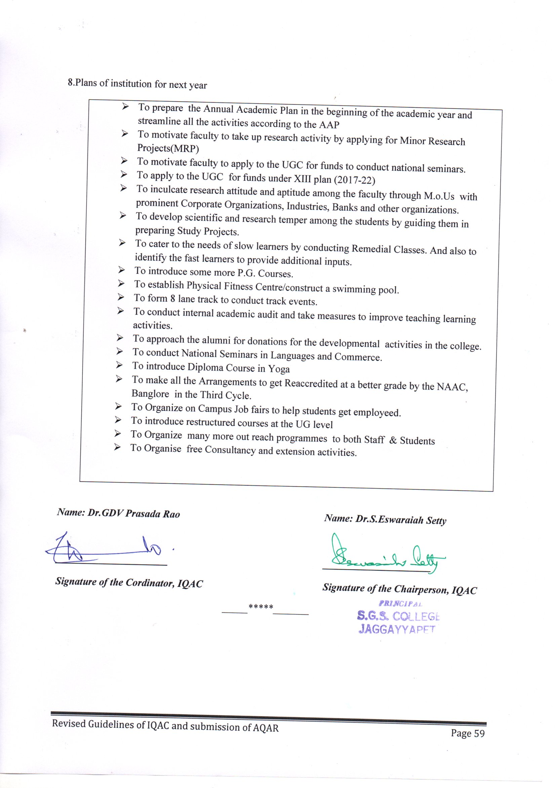
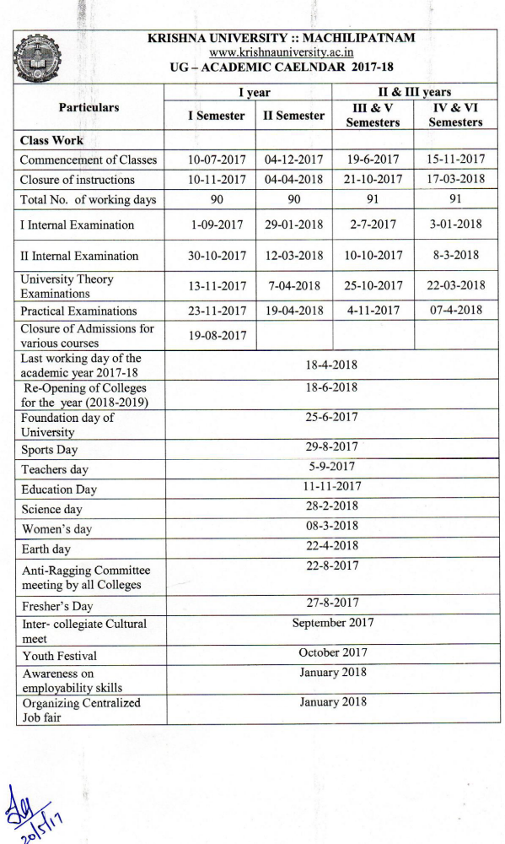
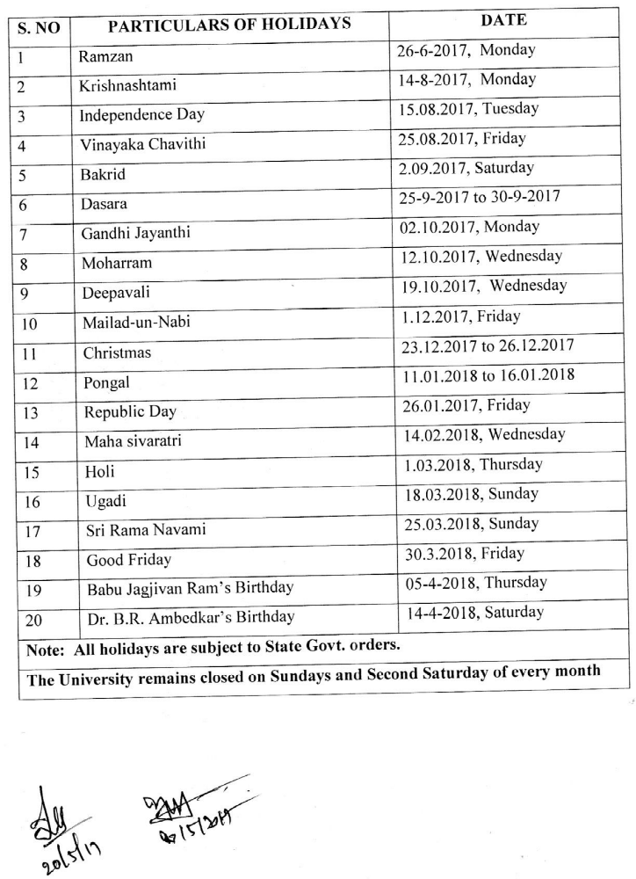

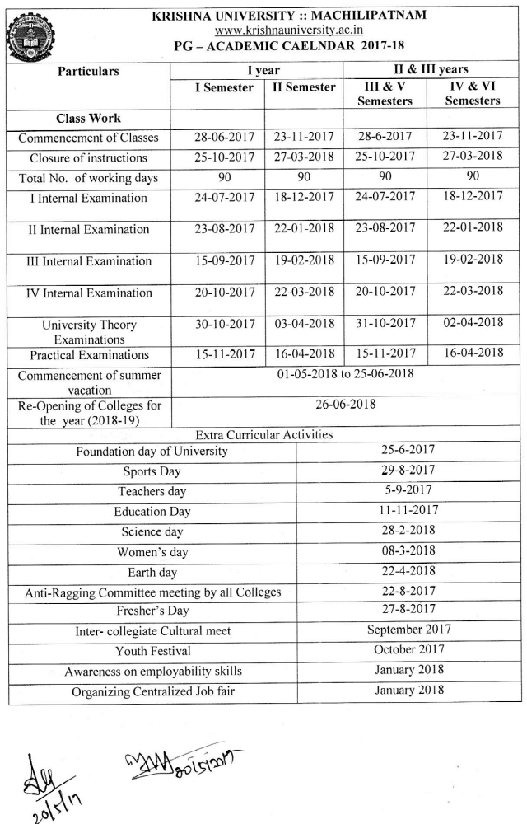

CURRICULAR PLAN 2017-2018
SI.No. | DATE | ACTIVITY NAME | GUEST NAME/INSTITUTION
1 | 12.06.2017 | Saraswathi Pooja | Management, Principal & Staff
2 | 21.06.2017 | Celebration of International Yoga Day Inguaration of a certificate course in Yoga | VVV Sky Trust
3 | 21.06.2017 | Inguaration of Free College Attached Hostel for meritorious women | College Management Committee
4 | 12.07.17 | Organized a Guest Lecture on Simplifying The Complex Calculations by the department of Mathematics | K.N.Ramesh, Principal, VBDC
5 | 14.07.17 | The First Day of the two day Visit to College by the NAAC Peer Team | 1.Prof. Sk.Pandey, Vice Chancelor Chhattisgarh, Chairperson 2.Prof. Sudipti Banerjea, Kolkata, Member Co-Ordinator 3.Dr.Veena Dada, Punjab,Member
6 | 15.07.17 | Final Day NAAC Peer Team Visit | 1.Prof. Sk.Pandey, Vice Chancelor Chhattisgarh, Chairperson 2.Prof. Sudipti Banerjea, Kolkata, Member Co-Ordinator 3.Dr.Veena Dada, Punjab,Member
7 | 19.07.17 | Voters Day Celebrations | Sri Manohar, DTO,Jaggayyapet  Sri T.Chandra Sekhar MRO,Jaggayyapet
8 | 19.07.17 | Blood Grouping Camp for freshers | Sri Samineni UdayaBhanu,President & Correspondent,College Management Committee
9 | 21.07.17 | Issuanse of certificate of latest NAAC Grading – “ B++ “ to College | NAAC , Bangaluru
10 | 25.07.17 | Announcement of latest NAAC Grade to college in its II Cycle in the Press Meet | Sri S.Udaya Bhanu & Members, College Management Committee
11 | 27.07.17 | A Guest Lecture The Unlimited power of mind Organized by Department of Commerce | Sister Lavanya, Faculty, M.B.A., Maris Stella College,Vijayawada
12 | 29.07.17 | Guest Lecturer The Trends in Communication & Soft Skills by the Department of English | Satish, Director, Race Coaching Centre,Jaggayyapet.
13 | 30.07.17 | Felicitation to Sri Y.Sambha Siva Rao,Head, ,Department of History on his Retirement | President & Correspondent and Members,College Management Committee
14 | 31.07.17 | Honouring the felicite,Sri S.Venkata Reddy, Co-ordinator, NAAC & IQAC and Head Department of English on his attaining super anivation. | President & Correspondent and Members,College Management Committee
15 | 03.08.17 | Conduct of Swatch Bharat | NSS 1 & II Units
16 | 08.08.17 | Anti Ragging Awerness Programme | Sri S.Priya Kumar, SI, Jaggayyapet
17 | 11.08.17 | A workshop on Leadership Qualities by the Department of Carrier Guidence | Sri N.Nithen Kumar, KCP Factory, Project Work
18 | 15.08.17 | Independence Day Celebrations | President & Correspondent and Members,College Management Committee
19 | 23.08.17 & 24.08.17 | A two-day workshop on Communication Skills Organized by the Department of Carrier Guidence | Sri Ch.Prabhkar, Trainer,APSSDC,Vijayawada
20 | 25.08.17 | Creating awairness on the use of ECO Friendly idols of Lord Vinayaka during the Festival of Vinayaka Chavithi | The Department of PG Chemistry
21 | 29.08.17 | Celebration of Freshers Day by the PG wing of College | Sri G.Gangadhar, Vice-President, Milon Pharma Citical Company,Mutyala
22 | 31.08.17 | Celebration of Freshers Day by the UG wing of College | Smt. G.Anatha Annapoorna, Bharatiya Satyavani, Social Activist
23 | 05.09.17 | Inguaration of Sri V.Visweswaraiah Municipal Botanical Park | President & Correspondent and Members,College Management Committee
24 | 06.09.17 | Felicitation to Teaching & Non-Teaching Staff on having been rated at B++ in the Second Cycle of NAAC reaccreditation | President & Correspondent and Members,College Management Committee
25 | 14.09.17 | Celebration fo Hindi Day by the Department of Hindi | Sri Sd.Moulali, High School , Asst.,ZP High School, Jaggayyapet
26 | 18.09.17 | Appreciating Jwala Narasimha Nayak of III B.Sc for participation in the Rifle Shooting Competition of the 19th NCC Directorate, North Eastern Region. He was declared the best Refile Shooter in State of Andhra Pradesh. | Principal & Major M .Swamy
27 | 20.09.17 | A Guest Lecture on The Latest Trends In The Field Of Genetics By The Department Of Zoology | Mr. Sk.Abbas Ali,Retd Head,Department of Botany,SGS College,Jaggayyapet
28 | 20.09.17 | Appreciating P.Dhanush of I CEC for his selection to participate in the School National Wait Lifting Competition | Management, Principal & Department of Physical Education
29 | 22.09.17 | Guest Lecture on Skill in English by Department of English | Sri U.Vasu Devara Rao, H.o.D. of English, KVR College, Nandigama
30 | 23.09.17 | Guest Lecture in Commerce Organiged by the Department of Commerce | Sri J.Tirupathi Rao, Vice-Principal, VBDC
31 | 25.09.17 | Conducted a Competition to Students on Bathukamma Dance,on the eve of Bathukamma Fest | College Students
32 | 21.10.17 | Work shop on Leader ship Qualities by Carrier Guidence Cell Presentation of Ideal | Sri N.Nithen Kumar, Madras Social work
33 | 21.10.17 | Field Trip to Cashewnut Unit,Autonagar by the Students of Commerce Department | Staff & Students
34 | 05 & 06.11.17 | The College Kabbadi Team Secured 4th place in the Krishna University Inter Collegiate Kabbadi Tournment for men held at SRR & CVR Degree College,Vijayawada | College Kabbadi Team
35 | 08.11.17 | Guest Lecture on The Application of Mathematical Differentiation and Integration in Real Life on the eve of Science Day by the Department of Mathametics | Dr.M.Siva Rama Krishna, Senior Scientist, Indira Gandhi Automic Research Center, Kalpakam, Tamilnadu
36 | 18.11.17 | Appreciating Vasanth Kumar of III B.SC for representing the College in the South Zone Inter University, Kabaadi Tournment for men held at Satyabhama University, Chennai. | Management & Principal
37 | 19.11.17 | Appreciating Ch.Naveen for representing College in the State Meet Kabaddi for men held at Chilimuru, Guntur District. The Krishna District Kabaddi Team Secured III rd place in the event. | Management, Principal & Physical Director
38 | 19.11.17 | Appreciating T.Anuradha of II BCOM for her remarkable Sports Man Ship in the South Zone Kabbadi for Women held at Mangalore University, Karnataka | Management, Principal & Physical Director
39 | 21.11.17 | Conduct of Open Deification Free Survey (ODF) at Anumanchipalli Village,Jaggayyapet Mandal by the NSS Units | NSS Officers and Voluntaries
40 | 25.11.17 | Conduct of State Level Mathamatical Olympaid | 300 Students from Various Schools and Colleges took the Exam
41 | 27.11.17 | Observation of Constitution Day by the Departments of  History and Political Science | Sri Y.Sambasiva rao, Head, Department of History & Sri P.Sambabu, Head, Department of Political Science
42 | 30.11.17 | Appreciating Ajithmiya of III B.COM and Jagadish III B.SC for their Active Participation in the NCC Trecking Camp Organized at Rajpal, Gujarat | Principal and NCC Officer
43 | 01.12.17 | An awairness talk on Aids and its Causes | Dr.Ayyappa Naidu, Govt. Hospital
44 | 07.12.17 | NIC Camp | NCC
45 | 11.12.17 | Participation in the World Telugu Conference by the Department ofTelugu | Faculty and Students of Telugu  Department
46 | 15 & 16.12.17 | Organized A two-Day Inter Collegiate Ball Badminton Tournment for men under the aegis of Krishn University, Machilipatnam. A College team stood 4th in the Competition held in the college | Management, Principal, Umpires and Teams from Other Colleges
47 | 18.12.17 | Organized a Campus Recruitment Drive to PG Students | 7 were Placed in the Sri Chaitanya  Educational Institutes
48 | 21.12.17 | Students of M.SC Chemistry took a Field Trip to Rachem Pharma Pvt. Ltd, | Faculty and Students
49 | 22.12.17 | One Day National Work Shop in Mathematics on the eve of Birth Anniversary of Sri Srinivasa Rumanian a Legendary Mathematician | 1. .Dr.M.Lakshminarayana, Controller of Examinations, Kru,Machilipatnam 2.Dr.M.V.Rajya Lakshmi,DEO,Krishna Dist.,Machilipatnam 3.Smt.L.Chandrika,DYEO,Nandigama Division
50 | 27-12-17 | Appreciating G. Suvarna Raju for his participation in the All India Ball Badmanton Tournament for men at Yogi Vemana University ,Kadapa, Andhra Pradesh | Principal & Physical Director
51 | 03.01.2018 | A Field Trip to Amoda Spintex by the students of Commerce Department | Faculty & Students
52 | 05.01.18 | Organized A State Level Elocution & Singing Competiton | Dr.G.Subba Rao, Chairman, GIST College, Bhimavaram, Jaggayyapet and participants from Various Other Colleges of the State
53 | 06.01.18 | A field Trip to Coca-Cola India Pvt Ltd., Atmakuru Unit,Guntur District,AP. By the Students of M.SC Chemistry | Faculty & Students
54 | 07.01.18 to 13.01.18 | Conducted A Special NSS Camp at Dhramavarapadu Thanda, Jaggayyapet,Krishna District. | A 100 Voluntaries took part in the Camp
55 | 11.01.18 | Apreciating R.Gangadhar,K.Jagadeesh, A.Rajavardhan, for having Bagged Two Gold Medals & One Silver Medal in the Ash-Te-Do Competiton | Principal, Physical Director, & Sk.Shareef Karate Master
56 | 23.01.18 | Students of M.SC Physics Paid a Visit to Ramco Cements Pvt. Ltd, Jayanthipuram | Faculty & Students
57 | 25.01.18 | Creating awareness to Young Stars on the eve of l Voters Day | Sri A.Nagaiah, Lect.in Politics, Vikas College, Nalagonda
58 | 26.01.18 | Celebration of 69th Republic Day | Sri M.Narasimha Rao,Tahsildar,Jaggayyapet
59 | 30.01.18 | Campus Recuirtment Drive | Sri Chaithany Educational Instutions
60 | 03.02.18 | Guest Lecturer on Human Values and Professional Ethics | Sri B.V.Ravi Kiran, Reporter, Eenadu, A Leading Daily News Paper
61 | 07.02.18 | Appreciating Ms. P.Anupama of Final MCOM and Retail Marketing for having placed in HCL Technologies Limited | Management & Principal
62 | 14.02.2018 | Guest Lecture on Building one’ scarrier | Sri P.Salmon Raj, Divisional Engineer, BSNL, Vijayawada
63 | 15.02.2018 | A talk on Action Research | Prof. R.Murali Krishna, Andhra University, Visakhapatnam
64 | 16.02.18 | Celebration of 51st College Anniversary | 1.Sri T.Radhesh Murali,Sub Divisional Police Officer,Nandigama 2.Dr.M.Lakshmi Narayana,Controller of Examination, KRU,Machilipatnam
65 | 28.02.18 | A talk on Science ToDay one the eve of Science Day Celebrations | Maj.S.V.Satyanarayana, Retd. Principal, SGS College, Jaggayyapet & Vice-President of GIST College, Bhimavaram, Jaggayyapet
66 | 08.03.18 | Celebration of International Women's Day | 1. .Dr.M.Jayasree, MBBS, Tejasree Hospital, Jaggayyapet 2. Smt.S.M.Maheswari, Asso.Prof. of English, Sri YN College, Narsapur
67 | 08.03.18 | Appreciating and encouraging B.GopiChand Nayak, I B.A, & G.Nikhil, I B.A for being Selected to Represent India in the Tennis Ball Cricket Tourney Conducted in Srilanka | Sri Y.Vinod Kumar, State Association Secretary, Management & Principal
68 | 09.03.18 | Paying homage to Lt.Vasireddy Rajyalakshmamma, Ex-MLA & Founder President, SGS College Management Committee | Management & Principal
69 | 15 & 16.03.18 | Conduct of External Academic Audit by the Commissionrate of Collegiate Education AP,Vijayawada | Sri E.Vara Prasad, Head, Department of English, KBN College,Vijayawada  Smt. E.Hepsiba, Lecturer in Chemistry, Siddartha College, Vijayawada.
70 | 18.03.18 | Statue unveiling Ceremony of Lt.Gonuguntla Nageswara Rao, B.A., Founder Secretary and Correspondent, SGS College Management Committee | Sri.SriramRajaGopal (Tataiah), MLA, Jaggayyapet,Constituency
71 | 02.04.18 | Installation of Cool & Mineral Water Stall at the APSRTC Bus Station to quench the thirst of Public During the Hot Summer Season | Sri Inturi RajaGopal, (Chinna) Municipal Chairman, Jaggayyapet  Sri Subbanna Reddy, APSRTC, Depot Manager,  B.Ramesh, Municipal Commissioner,Jaggayyapet
72 | 18.04.18 | Foundation Laying Ceremony of Daining Hall & Gym | Management & Principal
73 | 17.05.18 | Conferred Professor ship to Dr.S.Eswaraiah Setty, Principal (FAC) & Dr.S.S.R.Chidambara Sastry, Faculty in Telugu under the Career Advancement Scheme (CAS) of the UGC | Management

Annexure -II
Part B – 1.3 Feedback from Students 2017-2018
Feedback is collected from the students by respective departments in the month of October, 2017. Feedback forms supplied to the students include 20 items on which students are asked to give their opinion on a Three point rating scale. The 20 items are as hereunder .
- Efforts to effectively cover 100% of syllabus.
- The interest generated in the students while teaching in the class room
- Clarity of expression while teaching the topic/lesson
- Depth of subject content explained
- Level of latest developments in the subject taught
- Use of other methods of teaching like classroom seminar, question - answer, group discussion etc., in the class room
- Encouraging questions on the topic in the class and clearing doubts
- Use of various teaching aids in the class room for better explanation of the topic.
- Quality of synopsis / notes on the topic supplied to the students.
- Aptitude shown in arranging field visits, guest lectures, study projects etc., in the subject.
- Encouragement and guidance given to students in reading library (subject and general) books and using internet.
- Encouragement and guidance given to students in giving classroom seminars.
- Regularity and seriousness in valuing the answer scripts of monthly tests and discussing the same with students.
- Remedial coaching and efforts made in preparing the students for University Examinations.
- Regularity and punctuality to the class
- Enthusiasm shown to encourage and guide students in curricular, co-curricular , extra-curricular activities and cultural, community services, etc.,
- Counselling and career guidance
- Accessibility of the lecturer outside the classroom for academic interaction.
- Personal care and affection while dealing with individual students and helping students.
- Overall opinion on the lecturer.
ANALYSIS ON FEEDBACK:
The institution has carefully analysed the feedback given by the students and has initiated appropriate measures and made suitable suggestions to the faculty after thorough discussion in the staff meeting.

Annexure - III
Best Practices in the College
- Effective Adjustment of Class work.
- Study Hours for UG Students
- Tutorial System.
- Ward Counselling .
- Extension / Guest Lectures.
- Establishment of Skill Development Center with the auspices of Andhra Pradesh State Skill Development Corporation (APSSDC,Vijayawada), Andhra Pradesh Information Technology Academy (APITA), Vijayawada.
- Creating awareness on Cashless Transaction
- Establishment of Government Educational Institutions Strengthening Association (GEISA).
- Organising National work shop in Mathamatetics
- Science Expo for School Students.
- Conduct of Talent test for school students
- Organising Knowledge Expo.
- Plantation by NSS and NCC Volunteers.
- Blood Donation by NCC,NSS Volunteers and Other Students.
- Blood Grouping for all Students.
- Field Visits.
- Organising Relief and Rehabilitation Camps Whenever Needed.
- Imparting Employability Skills to the Students.
- Campus Keeping Initiatives / Clean and Green Programmes.
- Anti – Ragging Awareness Programmes .
- Promoting Social Response among the Students
- Organising Cultural Activities.
- Establishment of MoUs with nearby Companies and Organizations.
- Optimum Utilization of UGC Funds.
- Supply of Mineral Water to the Staff as well as Students.
- Distribution of Text Books and Note Books to the Poor Students through Bookbank.
- Extension of Library hours Whenever Needed.
- Payment of College Fees by the Staff for Poor Students.
- Organizing Awareness Programmes for Women Students through Women Empowerment Cell ( WEC )
- Implementation of Swatch Bharat Programme of the Central Government.
- Awareness Programmes for the Students in Matters of Conserving Resources like Water , Trees , Soil, Electricity, Oil , and Pollution Control of all Kinds.

- Services by the Dept. of Library Science :

- Information Display on the Notice Board concerning Employment Opportunities and Further Education.
- Guidance on Entrance Exams and their schedule

- Value Based Education

Along with curricular, co-curricular and extra – curricular activities, students are given
instruction in value based education.

- Extension programmes are organized to instil in the students social and civic responsibilities.
- Personal skills are developed through lectures delivered by experts in their respective fields.
- Measures are taken to enhance confidence of the students to participate in public speaking and cultural activities .
- Instruction on moral education is given through the writings on the walls, charts, maps, pictures , Power Point Presentations etc.
- Now and then guest lectures on spiritual education which is basically aimed at teaching moral values of life are arranged.
- In this direction the affiliating university in consultation with the Commissionnerate of Collegiate Education , has introduced a compulsory paper on value based education entitled as “ Human Values and Professional Ethics “ with a view to making the students responsible and exemplary citizens of the society.

Annexure - IV

Part B- 7.3 Best Practices.
- Supply of cool drinking water in the hot summer:

Objectives:
- To aptly fulfil the minimum corporate social responsibility.
- To provide clean, cool and refreshing drinking water to the passersby.
- To minimise the adverse impact of summer hardships normally experienced by the people of Jaggayyapet and surrounding places.

Needs identified:
- To quench summer thirst of the bus passengers and pedestrians.
- To counteract dehydration normally caused by scorching heat in Jaggayyapet which is usually prone to high radiation.

Practices:
- A drinking water stall has been arranged at the bus stand in the heart of the town to quench the thirst of the passersby.
- A person has been given employment to supply required drinking water to the needy from 7 am to 7 pm.

Evidence of success:
- Everyday a large number of commoners are getting benefit from this arrangement.
- Every year the project is well patronised.
- This has added a new dimension to the image of the college amongst the beneficiaries.
- It is learnt that the same practice has also been emulated by other institutions in and around Jaggayyapet.

Resources:
- The College Management is kind enough to sponsor amply for this public cause.
- Local Municipality has been contributing adequately for the same purpose.
- People with a philanthropic outlook too have been the patrons of this value added task.

- Organizing Knowledge Expo.
Objectives:
- To help students develop creative thinking.
- To help students exhibit their presentation skills.
- To help students to prepare models that represent real life entities.
- To present students optimum understanding of various concepts by way of science models, posters, etc. which they learn in the regular classwork.

Needs Identified:
- To help students to showcase their academic talent.
- To help students to trade their ideas with others.
- To bring various artefacts and varied exhibits on to a single platform.

Practices:
- Very often, college organises Knowledge Expo, an event in which students of different schools and our college meet and exchange their expertise on a common arena.
- This initiative is benefiting college, participating educational institutions and society at large.

Evidence of Success:
- Hundereds of school students participated in the event while thousands visited the spectacle and were amazed to see the grant exhibits and presentations that were made available.
- The students who visited the college got excited on seeing our well equipped labs, available infrastructure, cozy atmosphere etc.
- Such events have marginally contributed for an increase in our admissions year on year.

Resources:
- Paraphernalia of college.
- Exhibits and model presentations brought from other educational institutions.
- Staff and students of government schools that come under Deputy Educational Officer(Dy.E.O.) Jurisdiction.

